April 26, 2019
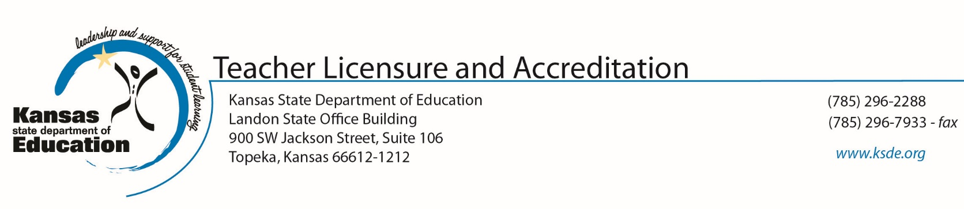
Dear Educator:
The Kansas Department of Education (KSDE) contracted with McREL International to develop perception surveys of school climate, professional development opportunities, organizational management, instructional practice, and student learning in your district.
The risks of participation are minimal. The feelings you may experience during the survey will be similar to those experienced during other opinion surveys. Your responses will provide valuable information on how you and other teachers in your district perceive the previously mentioned concepts.
Your responses will only be viewed by school/district officials as part of the Kansas Education Systems Accreditation (KESA) process. Any data your district chooses to provide to KSDE will be district averages. No personally identifiable information will be accepted by KSDE.
Your participation is determined by your district administration.
If you have any questions about this survey or your part in it, please contact your school principal. You may also contact KSDE accreditation staff at 785-296-8012 or accreditation@ksde.org.
Respectfully,
Mischel Miller, Ed.S., Director
Teacher Licensure and Accreditation
Jeanette Nobo, Assistant Director
Teacher Licensure and Accreditation

