In support of Kansas’ vision for education, the Kansas State Department of Education is accepting applications for school districts to participate in the Apollo Kansans Can School Redesign Project.
Districts selected for the Apollo Project may designate one or more elementary and/or secondary school - to be redesigned around the five outcomes established by the Kansas State Board of Education, the five elements identified as defining a successful Kansas high school graduate and what Kansans told us they wanted schools to look like in the future.
These districts will serve as demonstration sites for other Kansas districts.

VISION:
Kansas leads the world in the success of each student.

Five outcomes:
- Social-emotional growth
- Kindergarten readiness
- Individual Plan of Study (IPS)
- High school graduation
- Postsecondary success

Definition of a successful high school graduate:
A successful Kansas high school graduate has the academic preparation, cognitive preparation, technical skills, employability skills and civic engagement to be successful in postsecondary education, in the attainment of an industry-recognized certification or in the workforce, without the need for remediation.

To be considered for the Kansans Can School Redesign Project, districts must:
- Be able and willing to completely redesign one elementary and/or one secondary school around the vision, outcomes and definition of a successful high school graduate.
- Each district and school must provide evidence and have approval by their school board with a vote; faculty with a vote of 80 percent in each building being redesigned; and support from the local Kansas National Education Association (KNEA) or other professional organization.
- Be able and willing to launch a new school design in the 2020-2021 school year.
- Be willing to serve as a demonstration school/district for others in Kansas to study, learn and visit.

For planning purposes, if your school/district is selected to be part of the Apollo mission, you can expect the following during the Plan Year:
- Weekly staff member time devoted to working on redesign. This includes both the biweekly, all-day regional workshops the school redesign team attends, as well as work done by the rest of the staff during the weeks between the workshops.
- Costs for substitutes and transportation for staff attending the biweekly regional workshops and also for staff to visit other Redesign demonstration schools in Kansas.

Submit the application electronically to tcote@ksde.org by April 5, 2019.
This application package contains the necessary information and form to apply for Apollo Kansas Can School Redesign project. If applicants have any questions or need additional information, please contact Deputy Commissioner Brad Neuenswander with the Kansas State Department of Education via e-mail at bneuenswander@ksde.org or by telephone at (785) 296-2303.

Division of Learning Services
Kansas State Department of Education
900 S.W. Jackson Street, Suite 656
Topeka, Kansas 66612-1212
(785) 296-2303
www.ksde.org
The Kansas State Department of Education does not discriminate on the basis of race, color, national origin, sex, disability or age in its programs and activities and provides equal access to the Boy Scouts and other designated youth groups. The following person has been designated to handle inquiries regarding the nondiscrimination policies: KSDE General Counsel, Office of General Counsel, KSDE, Landon State Office Building, 900 S.W. Jackson, Suite 102, Topeka, KS 66612, (785) 296-3204

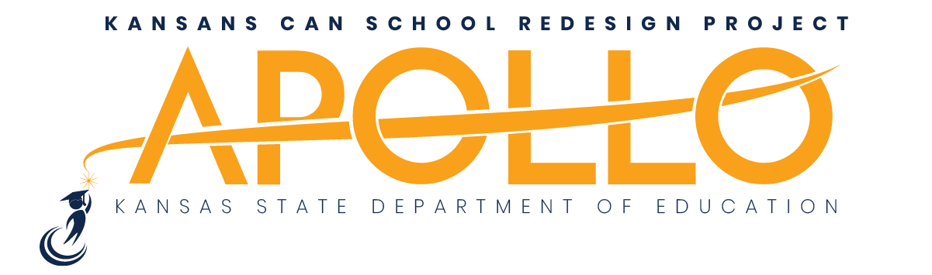

SCHOOL DISTRICT APPLICATION
District name/USD No.: | Click or tap here to enter text.
District address: | Click or tap here to enter text.
City: | Click or tap here to enter text.
Zip code: | Click or tap here to enter text.
Contact name: | Click or tap here to enter text.
Email: | Click or tap here to enter text.
Phone: | Click or tap here to enter text.
Superintendent: | Click or tap here to enter text.
Local school board president: | Click or tap here to enter text.
Date approved by local school board: | Click or tap to enter a date.

Names of the elementary and/or secondary schools designated to take part in the redesign efforts.
Elementary: | Click or tap here to enter text.
Secondary (middle or high school): | Click or tap here to enter text.

Why does your district want to take part in the redesign efforts?
Click or tap here to enter text. (Page will expand to accommodate length of response.)

What current efforts does your district have in place that align with the state board’s vision?
Click or tap here to enter text. (Page will expand to accommodate length of response.)

Assurances checklist:
☐ | Local board approval. Date: | Date approved.
☐ | Faculty vote with 80 percent approval. Date: |  | Date approved.

☐ | Local KNEA or other professional organization support. Letter of support.

Signature of superintendent: |  | Date: | Click or tap to enter a date.
Signature of board president: |  | Date: | Click or tap to enter a date.

Submit the application electronically to tcote@ksde.org by April 5, 2019.

