CHALLENGE AWARDS
Criteria

The Challenge Awards were created to honor schools that performed well on the state assessments and had high percentages of students from disadvantaged backgrounds, including those who live in poverty, and often members of a minority group.
Administrators and teachers have started to see the Challenge Awards as motivation to reach for even higher levels of performance. The awards help showcase the many positive academic achievements taking place in schools with predominately high-risk populations.

How does a school earn a Challenge Award?
The Challenge Awards recognize schools for outstanding achievement and uncommon accomplishment based on Kansas math and reading assessment results and other qualifying factors, specifically the sample size, ethnicity and social-economic status of those taking the test. We also now include graduation rates when calculating high school results and chronic absenteeism rates for middle and elementary schools. The steps used to identify Challenge Award honorees are as follows:
- A statistical model is used that includes 2018 math and reading state assessments scores, percent of the sample that received free or reduced-priced lunch and the percent that were members of an ethnic minority. Graduation rates and chronic absenteeism are factors, too. The top 200 Kansas schools are then selected.
- Only schools that have a total percentage of free and reduced-price lunch students above the state average of 46.49 percent are eligible for recognition.
- The schools are then sorted into State Board of Education districts.

For more information, contact:
Denise Kahler  Director  (785) 296-4876  dkahler@ksde.org  Tamla Miller  Administrative Specialist  (785) 296-4950  tmiller@ksde.org | 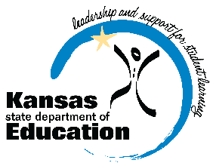 | Communications and Recognition Programs  Kansas State Department of Education  900 S.W. Jackson Street, Suite 102  Topeka, Kansas 66612-1212  www.ksde.org
The Kansas State Department of Education does not discriminate on the basis of race, color, national origin, sex, disability or age in its programs and activities and provides equal access to the Boy Scouts and other designated youth groups. The following person has been designated to handle inquiries regarding the nondiscrimination policies: KSDE General Counsel, Office of General Counsel, KSDE, Landon State Office Building, 900 S.W. Jackson, Suite 102, Topeka, KS 66612, (785) 296-3204

