Present: Brad Neuenswander, KSDE;
Charles I. Rankin, Ph.D., Kansas State University;
Janice Suzanne Smith, Children’s Cabinet and Trust Fund
Idalia Shuman, KNEA
Tony Moss, KSDE

Brad Neuenswander summarized the history of academic gaps and an earlier gap workgroup: state assessments have shown a gradual closing in academic gaps, as measured by either percent proficient or the Academic Performance Index, in reading and math from 2000 through 2011. But in 2011, White and Paid Lunch students leveled off in the low 90s, while the lower-income, Black, and Hispanic students began declining, which widened the gap.
Because of the expansion in the gap, the former Commissioner, Diane DeBacker, assembled a work group which explored where gaps were most pronounced. The first workgroup did not complete any recommendations before Diane resigned.
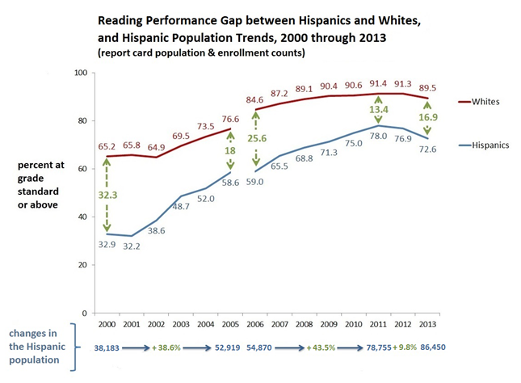
Brad, as acting commissioner, assembled this second workgroup and asked the group to:
- Decide what the group’s final product will be: policy recommendations, legislative changes, or other gap remedies.
- Decide what we need to know to make informed recommendations, legislative changes, etc. Then Tony, KSDE staff, would put the info together for the following meetings.
Brad wants the group to identify where interventions should be tested. Who are and where are the students who are chronically behind? In what districts? What do we know about these students, their schools, and districts?
He also described his vision of a more coordinated effort from pre-Kindergarten through higher education, with the ultimate goal of getting good, middle-class jobs for all students in Kansas.
Idalia suggested the group focus on the educators in the districts with the largest gaps—what do they see as the causes? She cited an example that used roundtable discussions that included everyone, students, too.
Charles suggested that teacher turnover was a problem in high-need districts. Another issue might be a lack of cultural competency on the part of some teachers. We may want to include representatives from the major schools of education in Kansas if we want to improve the training of teachers, (for improved cultural competence, etc.). Vouchers, too, might be an option to consider.
Janice said that whatever the group does, it should include some representatives from the private sector. They might help with financing whatever tasks the group takes up, and, more importantly, help advance solutions with legislators.
She suggested we talk to Ms. Shannon Cotsoradis, President & CEO, Kansas Action for Children, and to the former Senate Majority Leader, and a member of the Children’s Cabinet Board, Jean Schodorf. She also described work being done by the Children’s Cabinet—the case studies of early childhood systems in Coffeyville and Liberal, for examples, and the TOPS program in Wichita. The Children’s Cabinet, in collaboration with KU’s Center for Public Partnerships and Research and Wichita State, is conducting an evaluation of the Cabinet’s grants for enhancing early childhood programs.
Tony Moss then reviewed the research (see the slide presentation What are gaps and what causes them 2014 August 11). The research led to these conclusions:
- Gaps are leading indicators of the health and competitiveness of a society. The smaller the gaps, the healthier and more economically competitive the society. The rapid growth in the proportion of single mothers is a global phenomenon, but countries that have high-quality Early Education and Child Care (EECC), universal access to health care, and high-quality teachers in every school, have practically eliminated the gaps associated with poverty and single-parenthood.
- Health and academic gaps, because of developmental sensitivities, originate in early child development and social interactions. Damage done to the architecture of developing brains and to biological systems can emerge years, even decades, later.
- Poverty, particularly for children of single parents, tends to damage the biological architecture of developing brains through certain stressors and diminished language exposures. This damage increases the probability of lower academic performance, heart disease, diabetes, mental illnesses, and many other illnesses and damaging behaviors.
- As income and wealth gaps have increased over the last three decades, the upper classes are investing more in their children, increasing academic gaps by 30 to 60 percent.
- Social and Economic Status (SES) has become a much stronger predictor of gaps than ethnicity or race. But lower SES, particularly the high-risk associated with single-parent poverty, is disproportionately greater among African-Americans and Hispanics.
Researchers can now show how poverty, through chronic stress, and a dirth of language and emotional play, suppresses optimal brain development and social and emotional skills:
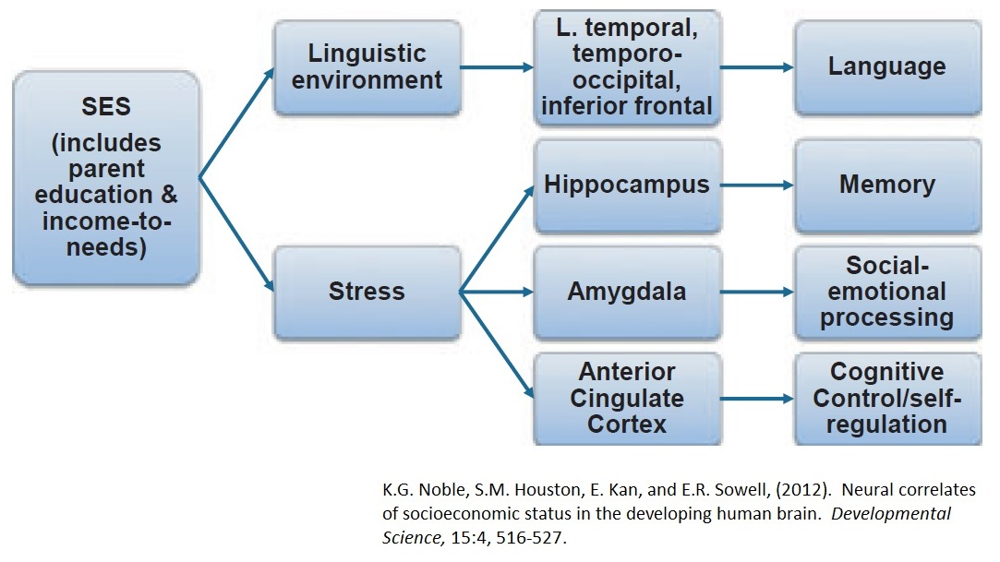
The 3 most important early factors for a child’s future academic success are:
- Rich language & intellectual stimulation and reciprocity
- Warm, positive bonding & attachment, emotional reciprocity
- Normal, not chronically stressful or neglectful, social environments
In practical terms, the sensitivity and plasticity of early childhood makes it the most cost-effective period in which to invest. Research indicates that high-quality investments in early childhood will ultimately reduce health, social service, and crime costs, and improve tax revenues and productivity, legislators from all spectrums should be able to support them.
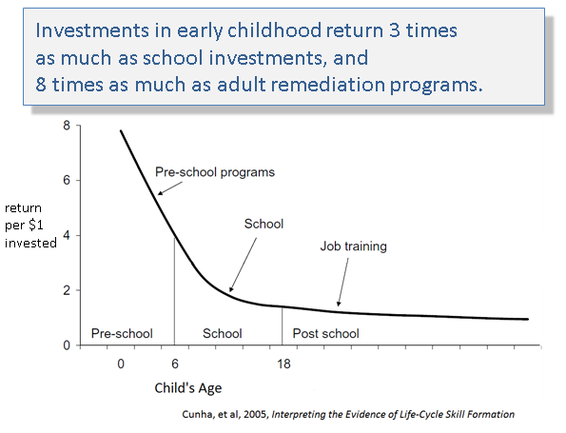
Because longitudinal data that can follow individuals across their life course, is relatively new, demonstrating the productivity of these investments has only recently been possible. Unfortunately, United States currently invests comparatively little in the early stages of life. Nationally, the U.S. spend one-and-a-half times the average of other wealthy countries on school-age children—about $12,000 per pupil per year—but almost nothing on very young children, though that is where we would get the most benefit from our investments. (See “Choose your parents wisely,” in The Economist, July 26th, 2014, 21-25). Our school curricula do not teach young people the basics of good parenting and healthy family life.
Next Steps: Brad will contact additional members about the next meeting. Janice will share documents from the Children’s Cabinet. Tony will prepare slides and data about where the largest numbers of gap students are concentrated, what we know about these districts and schools, and what we know about teachers in these districts.

