Strategy Evaluation - Discussion

Purpose- In order to ensure the successful implementation of any strategy (new or old), inquiry cycles must be well established. By working through these discussion questions, you will be able to determine which areas of the implementation process you will need to support before implementing any new strategies. Moreover, if you’re unable to answer these questions about your current work, then your teams will need to start by working to establish inquiry cycles to examine your current practices before adding in anything new.

Key Concept- Inquiry Cycles
This cycle can be used to move you through an entire growth cycle, but it can also be used to move a strategy from one stage to the next as well. Think about how this cycle can be implemented at the strategy level as you work through these discussion questions.
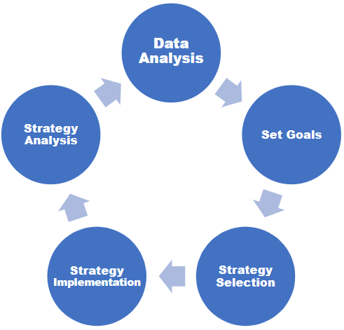

Discussion Questions-
- What might be some ways you would document your work as you implement inquiry cycles in your district/buildings?
- What processes do you currently have in place to monitor evidence of impact in your district?
- What processes do you currently have in place to monitor the fidelity of implementation in your district?
- How often are you currently looking at data to determine effectiveness?
  - Note - This is the time to discuss having consistent conversations around the data. For example, a 3-6-9 model (PLCs/Classrooms every 3 weeks, BLTs every 6 weeks, DLTs every 9 weeks) is a structure that keeps the entire district on the same page when it comes to reviewing data and inquiry cycles.

