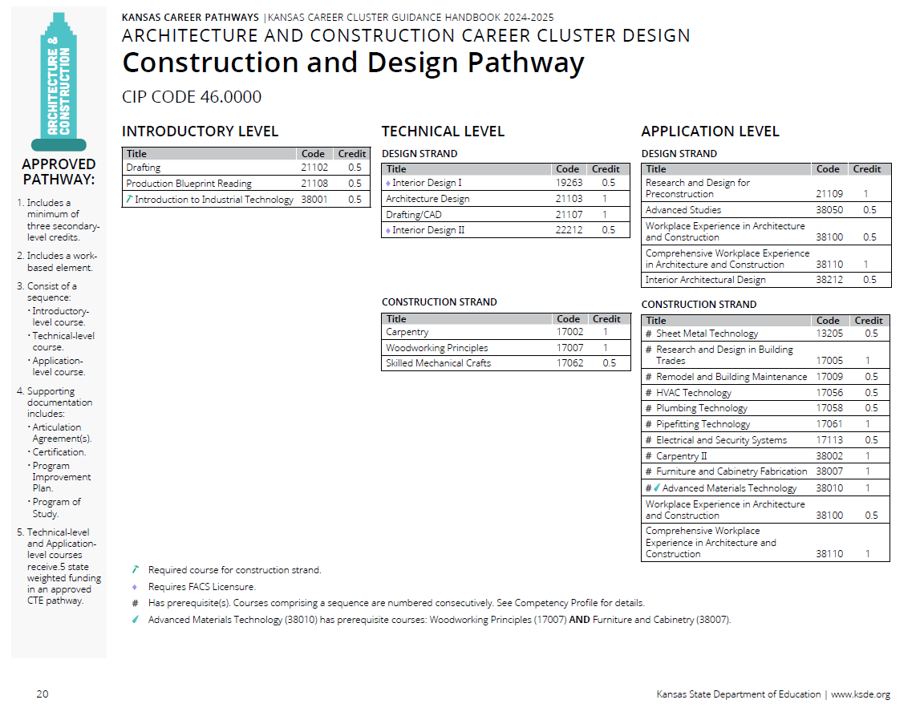
Prior to the Cluster Review

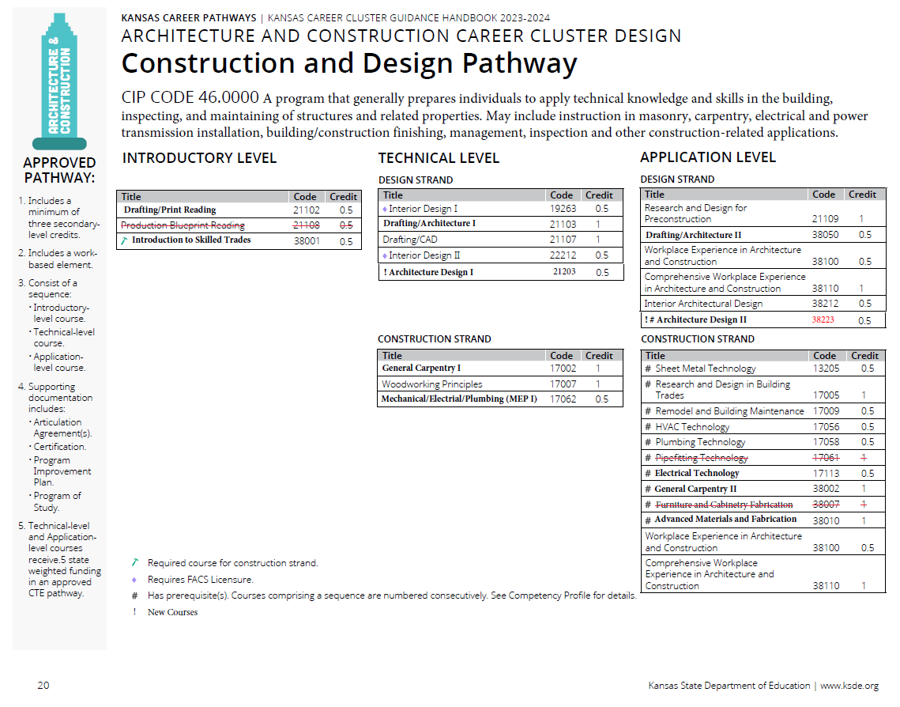
Recommendations Following Cluster Review

Pathway Recommendations Summary:

No Recommend Changes CTE Course Competencies and Indicators (ksde.org)
- Courses not reviewed by this committee.
  - 19263 Interior Design I
  - 21107 Drafting/CAD
  - 22212 Interior Design II
  - 13205 Sheet Metal Technology
- Courses Reviewed with no changes.
  - 38100 Workplace Experience in Architecture and Construction
  - 38110 Comprehensive Workplace Experience in Architecture and Construction
Courses Reviewed with Recommended Changes
- Courses being removed from the pathway.
  - 21108 Production Blueprint Reading
  - 17061 Pipefitting Technology
  - 38007 Furniture and Cabinetry Fabrication – combined with 38010 Advanced Materials Technology
- Courses with updated competencies and benchmarks
  - 21102 Drafting – changed to 21102 Drafting/Print Reading
  - 38001 Introduction to Industrial Technology – changed to 38001 Introduction to Skilled Trades
  - 21103 Architecture Design – changed to 21103 Drafting/Architecture I
  - 17002 Carpentry – changed to General Carpentry I
  - 17007 Woodworking Principles
  - 17062 Skilled Mechanical Crafts – changed to 17062 Mechanical/Electrical/Plumbing (MEP 1)
  - 21109 Research and Design for Preconstruction
  - 38050 Advanced Studies – changed to 38050 Drafting/Architecture II
  - 38212 Interior Architecture Design
  - 17005 Research and Design in Building Trades
  - 17009 Remodel and Building Maintenance
  - 17056 HVAC Technology
  - 17058 Plumbing Technology
  - 17113 Electrical and Security Systems – changed to 17113 Electrical Technology
  - 38002 Carpentry II – changed to 38002 General Carpentry II
  - 38010 Advanced Materials Technology – changed to 38010 Advanced Materials and Fabrication

New Course Recommendations
- Courses Recommended to be Added.
  - 21203 Architecture Design I
  - 38223 Architecture Design II

