Resolution to Adopt Budget
Second Publication - Property Tax Review

KSA 79-2925b requires school boards to adopt the budget by resolution IF the taxes levied will exceed the prior year by more than the consumer price index (CPI). In other words, if the 2nd publication is necessary, the board should adopt the budget by resolution (sample below). Include the Board of Education vote (i.e. Approved 7 Disapproved 0 ) and Board Clerk’s signature when the notice is published.

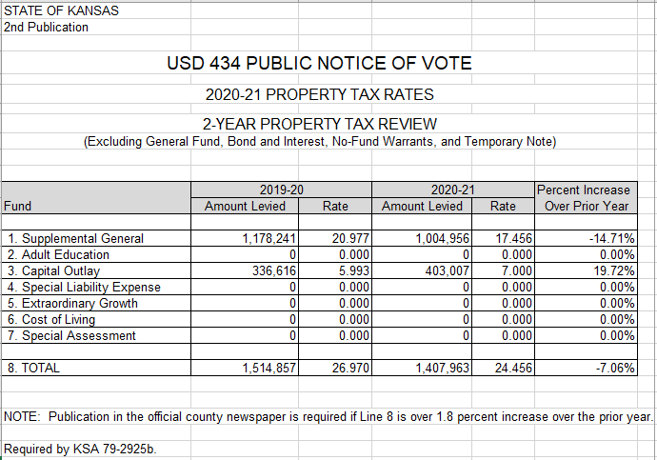
Second Publication

(form in Budget Codes.xlsx)

Your budget data will automatically be populated into this form and note if 2nd publication in the local newspaper is required.

Craig Neuenswander
craign@ksde.org
School Finance
(785) 296-3872

SAMPLE RESOLUTION BELOW: Wording that explains the tax increase may be added. The resolution may be signed by the board clerk, president of the board, and/or members of the board. Please include a copy of the resolution to adopt the budget along with the 2nd publication when submitting the budget document to the county clerk and KSDE, School Finance. If publishing later, email proof of 2nd publication to: sroot@ksde.org.

RESOLUTION NO.______

A resolution expressing the property taxation policy of USD 000 [district name] with respect to financing the annual budget for 2020-2021

Whereas, K.S.A. 79-2925b, as amended, provides that a levy of property taxes to finance the 2020-2021 budget of USD 000 exceeding the amount levied to finance the 2019-2020 budget of USD 000, as adjusted to reflect changes in the Consumer Price Index for All Urban Consumers for calendar year 2019, be authorized by a resolution.

NOW, THEREFORE, BE IT RESOLVED by USD 000 that the 2020-2021 budget with a levy of property taxes exceeding the amount levied in 2019-2020, as adjusted pursuant to K.S.A. 79-2925b, as amended, is hereby adopted.

Adopted this _____day of____________, 2020 by USD 000 [county name] County, Kansas.

[District name]
________________________
________________________

Kansas leads the world in the success of each student.
P:Budget/Budget Sample 2021/Resolution 2nd Pub

