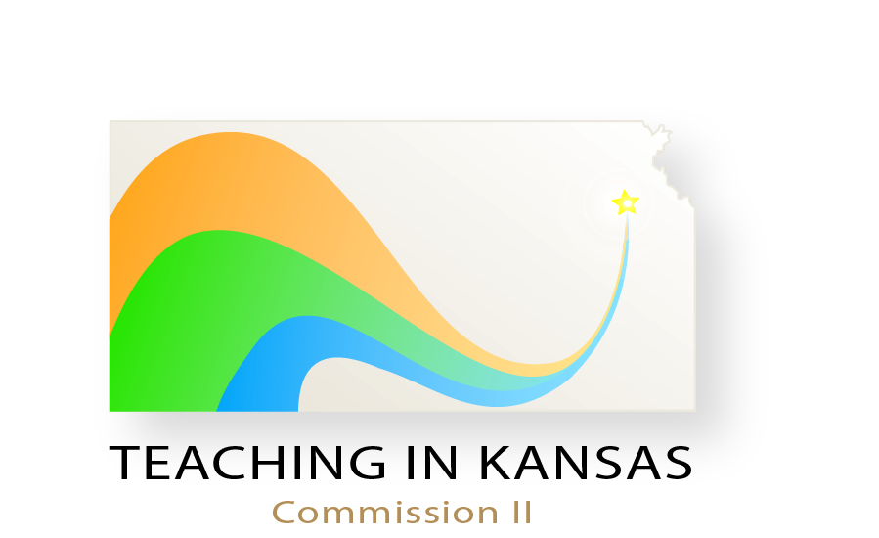
October 19, 2012
Agenda
Welcome

State Information
--Survey—

Information from Other States

Formation of Work Groups

Closing Remarks

