April 26, 2019
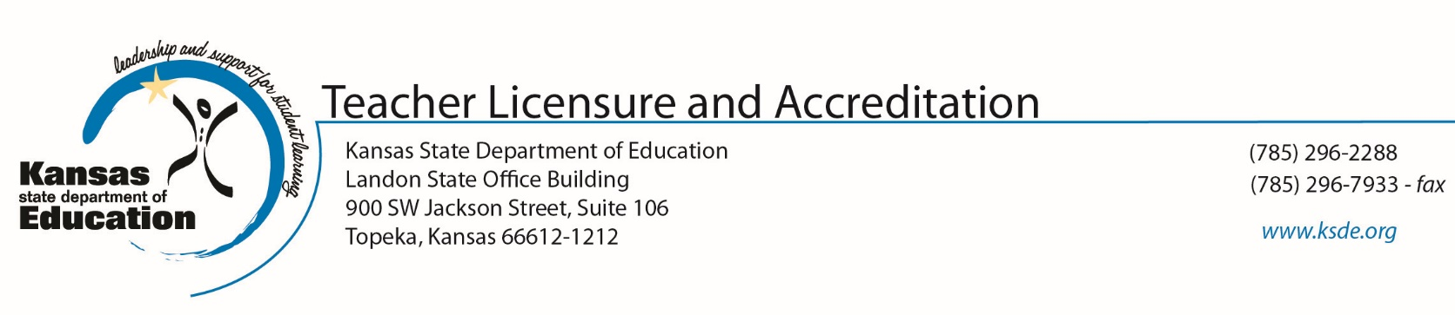
Dear Families:
The Kansas State Department of Education (KSDE) has contracted with McREL, a non-profit organization, to gather information related to student perceptions of learning. The survey does not interfere with your child’s normal curriculum.
The risks of study participation are minimal. The feelings your child experiences during the survey will be similar to those experienced during typical opinion survey. A benefit of allowing your child to participate is that your district will gain a better understanding of how educators impacts students.
Your child’s responses will be used only for statistical purposes. The responses will not influence your child’s status at school. Any data your district chooses to provide to KSDE will be district averages. No personally identifiable information about you or your child will be accepted by KSDE.
Your child’s participation is voluntary. If you do not wish your child to take the survey, please fill out the form on the next page and send it back to your child’s school. Important: If you give your child permission to take the survey, do not sign the form or send it back. If we do not receive a form from you, we will assume your child has permission to take the survey. You may change your mind and withdraw your permission at any time.
If you have any questions about this survey or your part in it, please contact your school principal. You may also contact KSDE accreditation staff at 785-296-8012 or accreditation@ksde.org.
Respectfully,
Mischel Miller, Ed.S., Director
Teacher Licensure and Accreditation
Jeannette Nobo, Assistant Director
Teacher Licensure and Accreditation

RETURN THIS FORM ONLY IF YOU DO NOT
WANT YOUR CHILD TO PARTICIPATE IN THE SURVEY.

If you DO NOT wish to give your permission, please:

- Write your child’s school name and his or her name in the blanks below.

- Check (“X”) in the box under it.

- Sign your name and write the date.

- Return this form to your child’s school by Date TBD

Thank you.

School Name: ____________________________________

Child’s name: ____________________________________

□ My child does NOT have my permission to participate in the student learning perception survey.

Parent’s Name Printed:
Parent’s Signature: ___________________________________

Date:

