Start with the best evidence about causes & remedies.
- Review Problem Definition
- Review Causes linked to Remedies
- Select Main Goals & Specify Objectives & Explain Reasoning
Planners say having fewer goals reduces complexity and increases the likelihood of success. What’s the appropriate scale of the objectives? Small & incremental? Big, bold, & comprehensive?

- Share Completed Individual Goals, Objectives, and Reasons with the Group. Let individuals revise their individual recommendations if they want to.
- Consolidate the individual goals & objectives. Share & discuss. Vote for specific ones.
After defining the best objectives, begin engineering trade-offs.
- Consider Context, Identify Audience and Final Products:
  - Placing the Gap Remedies within a B-24/preK-20 Proposal (Brad)
(Propose a Process? A research/policy engine?)
  - Identify and consult with Allies? hosting communities support? Hosting institutions support? Employers? Parents? Teachers?
  - Identify Opponents: anticipate objections & address them
  - Consult with bureaucratic actors & get their responses to the proposal: Criminal Justice; Social Services; Health & Environment—allies?

- Affordability: Defining alternatives:
  - Scale and locations
  - Sources of funding:
  - costs of high-quality personnel over a prolonged period of time
  - How will high-quality providers / teachers be retained in highest-need schools & neighborhoods?
  - Measure developmental changes and do cost/benefit analysis?

- Mobilizing political support for submission & adoption

- Review Problem Definition
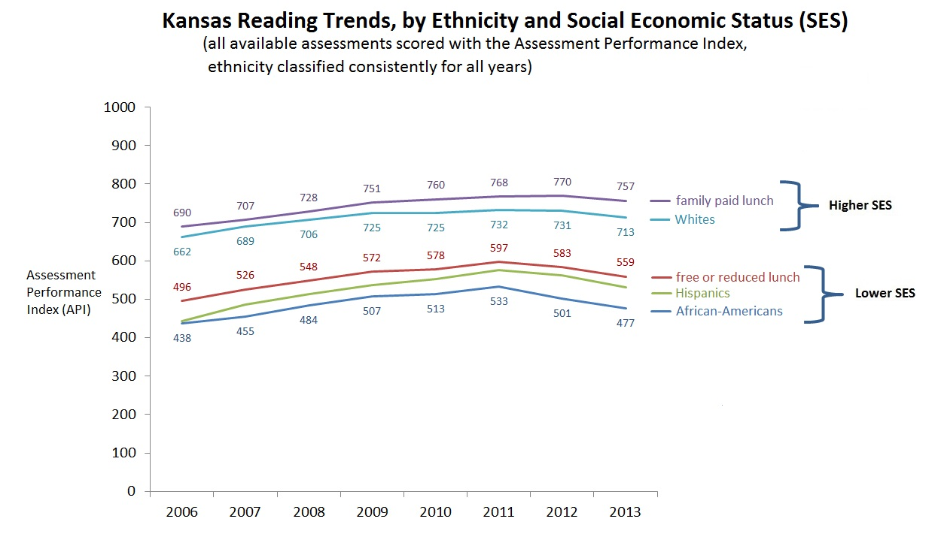
In 2011, academic gaps, between children from higher socio-economic-status families, and children from lower SES families, as measured by State assessments, began to expand, and continued to do so for the following two years. Among Hispanics and African American children, poverty rates, as measured by free-or-reduced lunch status, are about twice as great as among White children, so the academic gaps between White children, and Hispanic and African-American children, also expanded during the same period.
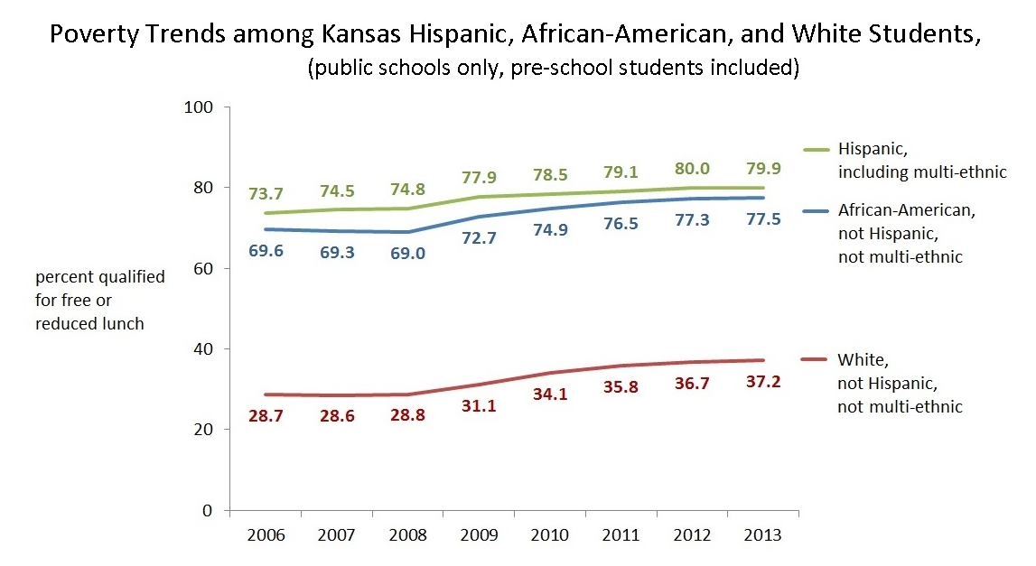
- Review Causes linked to Remedies (summarized from research; see What are the most promising solutions.)
Early Childhood Causes | Remedies
- Poverty Risks and Genetic Interactions: Poverty often comes with stressors and risks which shape the biological architecture and social habits of developing children. Once the architecture of developing brains and biological systems are sculpted by early experience, gradients in language skills, health, and social skills appear early, persist, and often grow larger.  - The low-quality of childcare available to low-income parents also suppresses optimum development for the same reasons above.  - Women with young children must work. The change from industrial to mass consumer societies, and the decline in marriageable men, has meant global increases in working, single mothers. In the U.S. about 68% of women with children younger than 6 also work. | Reduce the stresses of maternal and child poverty, improve the quality of parenting, and improve developmental environments, especially in the first 5 years of life.  - Provide high-quality, center-based Early Education and Child Care (EECC) targeting low-income, stressed parents (e.g. Chicago Child-Parent Centers)  - “High-quality” = teachers with bachelor’s degrees in EECC, selected for warmth and commitment to children; low child-to-teacher ratios  - Improve the quality, hours, and availability of Head Start.  - Combine services for parents and young children, e.g.,  EECC + Associates/BA degrees in same location;  EECC + Job training, certification in same location;  - Visiting nurse programs for high-risk (must be well-trained)  - Teach new parents about optimum child development through all available channels, pediatricians, WIC, Parents-as-Teachers, family literacy programs like 30 Million Words, Head Start, Incredible Years, middle/ high school curriculum  - One-stop shops for integrated early childhood services in elementary schools  - pre-Kindergarten for 4-year-olds (again with well-trained teachers with 4-year degrees in EECC).  - Improve early identification of suppressed development and apply new curricula designed to strengthen specific parts of the brain, e.g. Tools of the Mind  - Smooth transitions between EECC, primary, middle, & high school to maximize parental engagement & reduce downward resorting

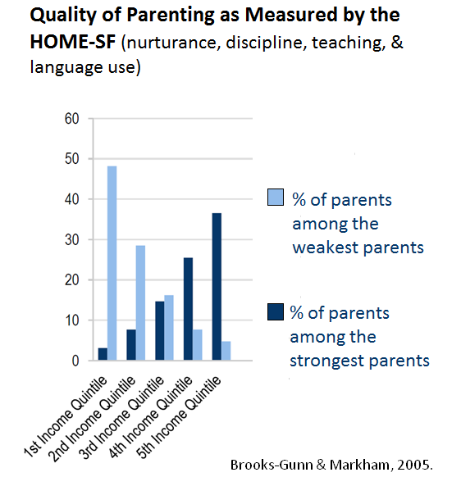

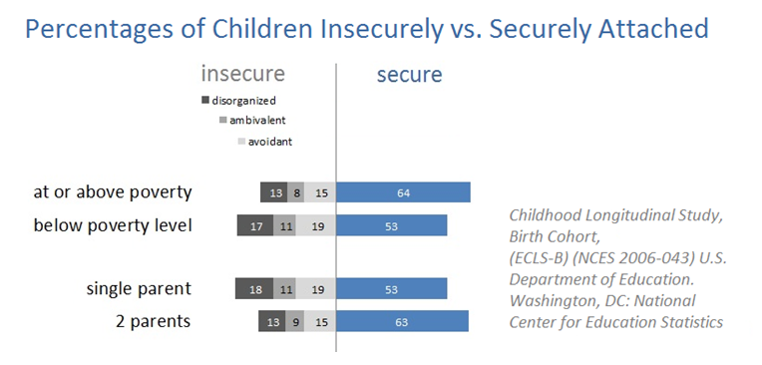
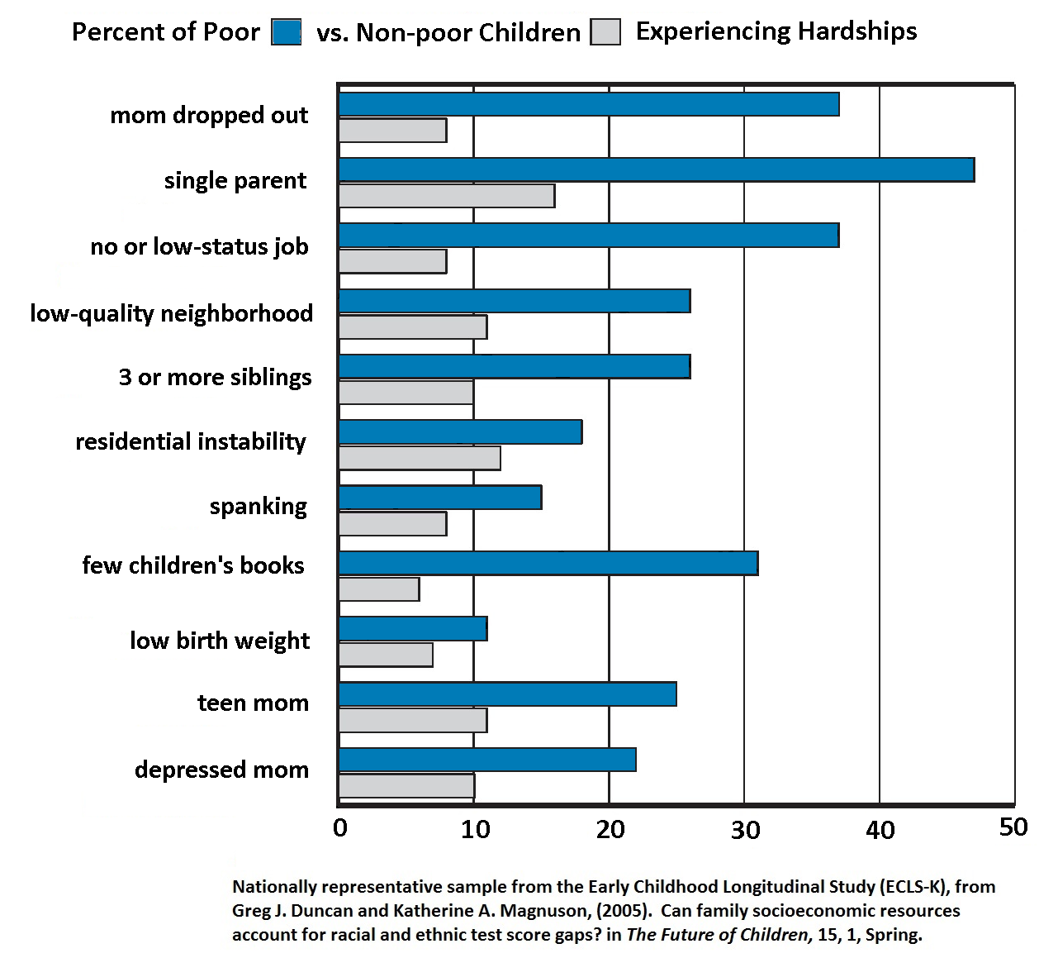

Socio-Political Causes | Remedies
Upper classes are spending more on their children. An estimated 30 to 60% of academic gaps are attributed to increases in the income and wealth gaps among adults—higher income parents are investing more in promoting their children’s abilities. Families and individuals compete for status and resources. | - At birth, start education savings plans with matching incentives for parents (like 529 savings plans, only publically matched funding on a sliding scale, depending on parental income). Allow this capital to be used to finance post-secondary education, or for starting a small business. [Are these like Michael Sherraden’s Individual Development Accounts?]

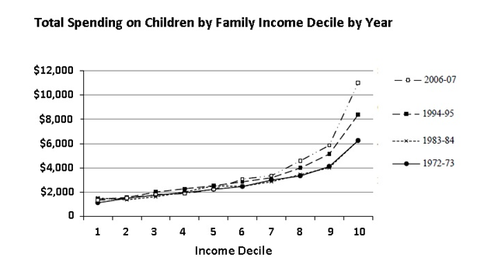

School-based Causes | Remedies
Teacher turnover Compared to high-performing countries with teacher yearly turnover rates of 1% to 3%, the ten Kansas districts we examined had rates from a low of 4% to as high as 10% and 14%.  Teacher selection, training & pay In 2006, Kansas teachers’ wages were only 70% of comparable occupations. Available data shows a yearly oversupply of teachers of about 2,000 registered teachers from 2007 through 2009, and then, from 2010, a decline in oversupply until 2013, the only year showing an undersupply. The profession is highly feminized (75%)—usually an indicator of lower status and pay. There are 4 times the percentage of African-American students as African-American teachers, and more than 8 times the proportion of Hispanic students as Hispanic teachers. We did not examine the selectivity of KS schools of education.  Peer and neighborhood influences In a hierarchical mixed model of predictors of student academic growth (see chart below), for each percentage increase in lower-income students, individual academic growth was suppressed. This was also true for increases in the percentage of Hispanic students. | - National examples, Long Beach school district (see chart 2 pages below), and international examples, Ontario, Finland, Singapore, Japan, and South Korea, have shown that high-quality training and coaching—something like the way the U.S. trains doctors—can greatly improve instructional quality and student academic performance.  - Finland, Singapore, Shanghai, Ontario, South Korea, and Poland, have shown that careful and limited selection of teacher candidates, for high academic performance—typically in the top 20 percent or higher--and for social skills, and a strong commitment to children, greatly improves instructional quality and student academic outcomes. To overcome the problem of selecting and training the best, and then keeping them in the highest need schools, Tony suggested using very generous scholarships to leverage placement agreements, something like the military trains pilots and then obligates their service for a decade.  - There are urban teacher training programs that have been successful, but they have not been provided training resources like the exemplars above.  - [We did not consider remedies for negative peer and neighborhood influences. Does the group know of some?]

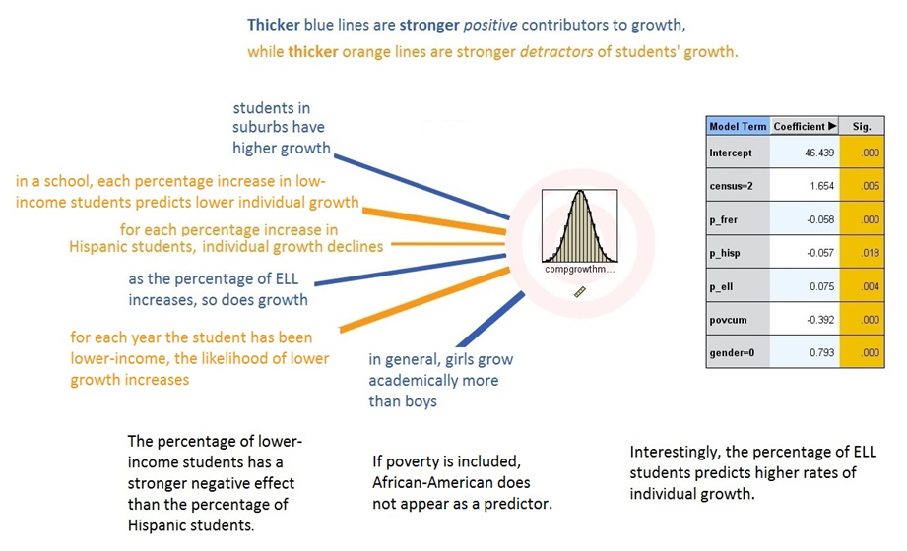

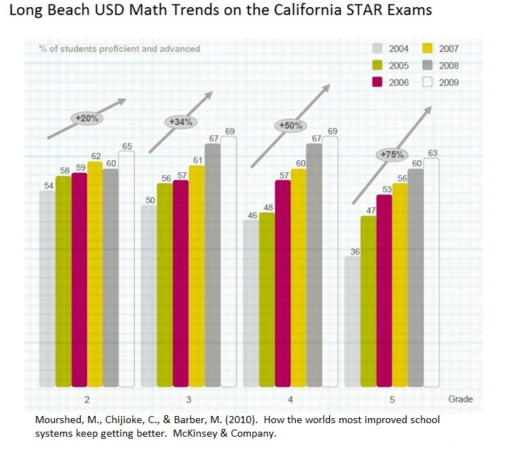
- Select Main Goals & Specify Objectives (These are the sections I’d like each committee member to fill out.)
Example: Goal #0 | Example: Specific Objectives | Criteria for selecting this goal?
- Provide high-quality, center-based Early Education and Child Care (EECC) targeting low-income, stressed parents (model: Chicago Child-Parent Centers). Add sector certification training and 2-year degree training in same location (EECC+)  - “High-quality” means staffed by teachers with bachelor’s degrees in EECC and selected for warmth and commitment to children; it also means low child-to-teacher ratios. | - Identify workgroup by Sept. 2015;  - Find 15-year sources of financial support by July 2016;  - identify district and local collaborators by Dec. 2016;  - begin hiring and training by Feb. 2017;  - open first of 10 EECCs in July 2017 in highest need community.  - Offer health care and adult certification and 2-year degrees for adults in same.  - Open 2nd EECC+ in Jan 2018. | Research (see summary in slides) has estimated that about half of the school readiness gap could be removed by high-quality EECC. The estimated benefits to costs ratios are very large, 8 to 1 to more than 26 to 1, and grow across the life span. For child participants, better physical and mental health, higher graduation and college attendance rates, lower crime rates, and higher earnings.  Combined with education services for primary caregivers, EECC+ programs offer even greater benefits—reduced caregiver stress, more economic opportunities for the family, more opportunities for interaction with other educated professionals, and improved knowledge of how to promote the development of children.  For employers, these programs can offer customized training for future employees, and lower employee absentee rates because parents have high-quality, secure, and reliable childcare for their children.

Goal #1 | Specific Objectives (appropriate scale?) | Criteria for selecting this goal?

Goal #2 | Specific Objectives (appropriate scale?) | Criteria for selecting this goal?

Goal #3 | Specific Objectives (appropriate scale?) | Criteria for selecting this goal?

Goal #4 | Specific Objectives (appropriate scale?) | Criteria for selecting this goal?

Goal #5 | Specific Objectives (appropriate scale?) | Criteria for selecting this goal?

- Consider Context:
  - Placing the Gap Remedies within a preK-20 Proposal (Brad’s mile-relay metaphor)
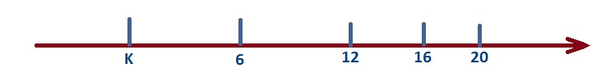
Discussion: How does the gap recommendation best fit into the Kansas College and Career Ready Goals? Our group will be merged with the preK-20. I suggest changing the name to “Birth-24 group” or “preN-24 group” for prenatal to 24 group. The latter names give appropriate importance to the architectural stage of development at the beginning of life. Once we have developed our recommendations, they will be integrated in a larger, more comprehensive proposal to the State Board of Education and the legislature.

What products are needed from this workgroup? Brad would like an integrated proposal for the State Board of Education and the legislature by Spring, 2016.

