Landon State Office Building
900 SW Jackson Street, Suite 653
Topeka, KS 66612-1212
www.ksde.org

Cross-Agency Workgroup Recommendations:
How Can Kansas Reduce Academic Gaps
Between Ethnic and Social-Economic Groups?

17 November 2015

Contents

The Purpose of This Report 1
Problem Summary 1
Review of the Evidence 4
The Method 4
Strengths and Weaknesses 4
The Workgroup’s Proposals 5
1. Community-Based Proposals 5
2. District & School Based 6
3. Parent-Focused Proposals 7
4. Government-Roles 9
5. Student-Focused 10
6. System-Focused 11
7. Teacher-Focused 11
Next Steps: Corrections & Priorities 12
References 13
Appendix A: Workgroup Members 15

The Purpose of This Report
Questions or comments?

Tony Moss
tmoss@ksde.org
785-296-6177

Career, Standards and Assessment Services
Kansas State Department of Education
Landon State Office Building
900 SW Jackson St., Suite 653
Topeka, KS 66612-1212
For questions concerning this report, please contact:
Tony Moss
tmoss@ksde.org
785-296-6177
Career, Standards and Assessment Services
Kansas State Department of Education,
Landon State Office Building
900 SW Jackson St., Suite 653
Topeka, KS 66612-1212
This report summarizes the policy proposals identified by the gap workgroup. It also plans the next steps to refine and validate the workgroup’s recommendations.

Problem Summary
Gaps are measures of the current and future vitality of a society. When academic and health gaps between ethnic and social-economic classes grow large, the likelihood of social, political, and economic instability grows larger, too (Piketty, 2013). Crime gets worse (Daly, et al); lives, shorter (Hertzman and Boyce, 2010). Many social problems also get worse (Pickett and Wilkinson, 2011; Frank, 2007). The talents of youth from the lower classes are undeveloped and wasted (Turkheimer, et al, 2003). Consumer buying power is limited and economic growth slows (Piketty, 2013). Individual destinies are more determined by the class of one’s birth, and less by effort, work, and talent. The work ethic is undermined (Frank, 2007; Piketty, 2013).

In an interdependent world economy, trade and migration are integrating labor markets. The skills and quality of a country’s labor force are a principal factor in economic growth. To better compete, countries must improve their human capital and manage it well (Hansson, 2009). This means they must improve their education systems and reduce skill and academic gaps. A country that fails to fully cultivate and utilize its human resources can expect relative social and economic decline.

From a leading position among industrialized countries after World War II, the United States is now behind many other developed nations in educational achievement, health performance, child welfare, safety, equality, class mobility, and other key measures (UNICEF, 2013).

In the United States, with its social contract of political and legal equality, and the promise of equal opportunity, the persistence of gaps has elicited great efforts to understand and reduce them. Since the 1966 Coleman Report, academics have worked to understand the causes of academic gaps, particularly between African-Americans and Whites. The No Child Left Behind Act (NCLB) invited the measurement of academic gaps by requiring the reporting of each state’s assessment scores by ethnic, language, disability and class subgroups.

In Kansas, with the implementation of NCLB in 2003, academic gaps gradually narrowed until 2011, when they began to widen again. In the chart below, showing Kansas reading trends, three facts are prominent. The first is that the gaps are remarkably stable. As students from higher social-economic-status (SES) groups move up, those in lower SES groups move up also, in close parallel, so that even as scores go up, the gaps stay at about the same width. One of the reasons for this, which the workgroup explored, is that families compete for status. As incomes have grown more unequal, families with means have been spending more on their children’s education and enrichment (Kornrich and Furstenberg, 2010). To close gaps, ideally, lower SES groups’ scores and capacities must move upward at steeper rates than higher SES groups. This is very difficult to achieve if families with greater means are competing through investments in their children. Reducing gaps may be impossible in a society of growing inequality that is unwilling to counter imbalances.
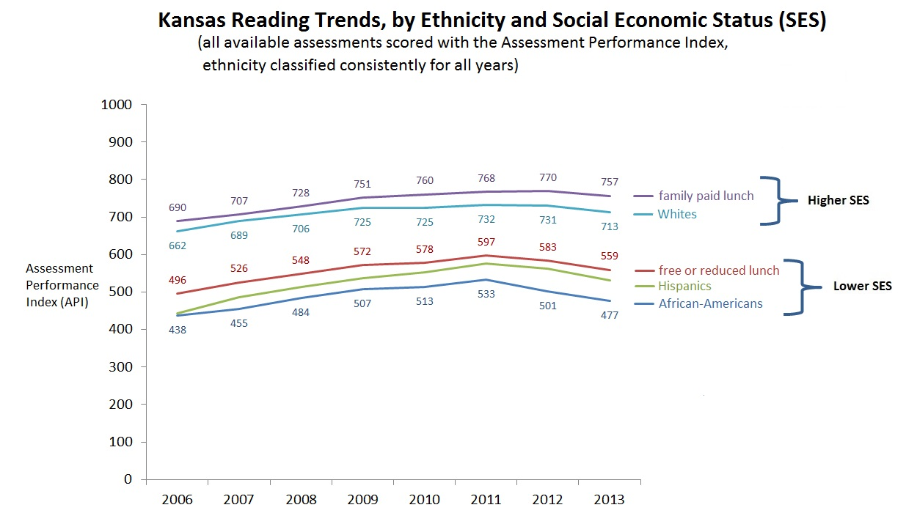

The second fact apparent in the chart above is that whatever efforts were being applied through NCLB and other efforts to reduce the gaps over this period, their effects were very gradual. This weak response suggests that NCLB was not directly or strongly influencing the main causes of academic gaps.

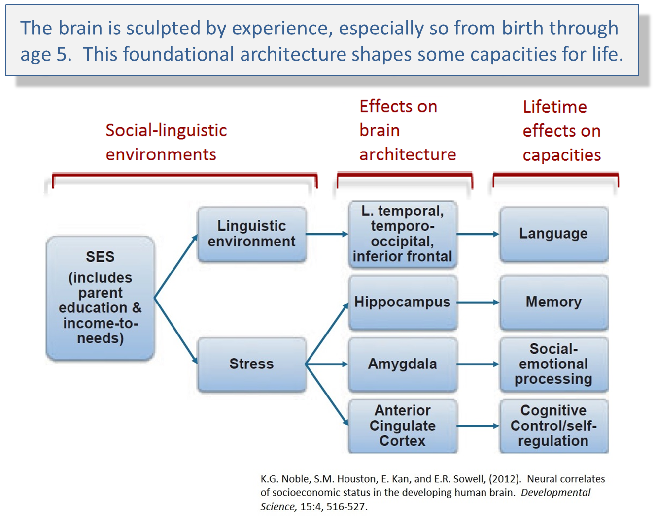
The third fact is that whatever provoked the decline in state assessments among lower SES groups in 2011, it first led to declines among lower SES students, and it did so more sharply than the leveling-off and then softer decline among higher SES groups. This underscores the greater vulnerability of lower-class students to the causes of academic gaps.

When academic gaps began to grow in 2011, they drew the attention of the State Board of Education. In 2013, the State Department of Education Commissioner, Diane DeBacker, asked agency officials and minority community representatives to serve on a workgroup that would investigate the causes of academic gaps and make policy recommendations to help close them. After Commissioner DeBacker resigned, acting Commissioner Brad Neuenswander reconvened the workgroup in August, 2014 (the membership is listed in Appendix A).

Review of the Evidence
In a series of monthly meetings lasting two to four hours, the workgroup reviewed research and evidence, and sought answers to these questions:

- What are gaps?
- What causes them?
- Which Kansas districts contribute the most to the State’s academic gaps?
- Which is a stronger predictor of gaps, economic disadvantage or ethnicity?
- What are the most promising solutions to reducing gaps?
- How much could Kansas save if it invested in high-quality early childhood education?
- What solutions does the workgroup recommend?

The most consequential evidence linked early childhood experiences and poverty, especially chronic stress, poor language experience, and less responsive care, to later risks of academic failure, weaker social skills, poorer health, and shorter life-spans (see the diagram above). The bright side of these dark discoveries is in the potential for prevention: effective changes in early childrearing and social experiences could improve the quality of life and the productivity of coming generations while reducing private and public expenses.

Slides summarizing the evidence the workgroup reviewed are available on Commissioner Randy Watson’s gap web page.

The Method
After reviewing the evidence answering the first six questions listed above, individual workgroup members submitted forms listing their recommendations for reducing gaps. NVivo, a text analysis software, was used to classify the recommendations.

Recommendations were classified by their focus or level. For example, proposals for community-based, one-stop services were grouped under the theme community-based, while those that proposed changes at the district or school levels were grouped under district and school based.

This approach facilitates the identification of different stakeholders. The proposals for community-focused changes can be reviewed by community-based agencies and members, while others proposing changes at the district or school levels can be reviewed by administrators, parents, and teachers.

Strengths and Weaknesses
The advantages of an expert work group are similar to those of focus groups: the members care about academic gaps. They want to identify proposals that will work. All workgroup members had worked for non-profit organizations, government agencies or educational institutions that had coped with academic gaps or the inequalities associated with them. Some had personal experiences with the disadvantages of poverty and discrimination. Expert work groups are a good first step in identifying problems and stakeholders, and in making initial proposals.

This strength, a small number of experts who are well-informed and care about an issue, can also be a weakness. Expert groups are not representative of all the stakeholders involved in an issue. While the workgroup was ethnically diverse, other stakeholders, for example, teachers and parents from communities with large academic gaps, or policymakers, were not represented in the workgroup. Expert groups can be prone to group-think—where ideas are limited by a few influential members, a particular frame of reference, ideological prohibitions, and other small-group processes that can limit information, and prevent the discovery of important facts (Suroweicki, 2005). They can also be too busy to fully contribute to an initiative.

Another limitation is the lack of priority. The gap workgroup identified proposed remedies, but it did not rank them in their importance as remedies. This document is a list, but other than noting the research that supported a proposal, it doesn’t qualify proposals by the magnitude of their likely benefit-to-cost ratio, by their political feasibility, or by any other criteria.

With these strengths and weaknesses in mind, this catalog of recommendations is a first step in a longer process. Refinement of the proposals by other groups, ranking the proposals by their likely benefits-to-costs, or by their political feasibility, are future steps considered at the end of this document.

Another weakness was that the classification of themes led to some duplication. Some proposals can be classified as belonging to more than one theme. For example, the proposal to offer mono-lingual, non-English-speaking parents English language courses can be considered as a parent-focused proposal, or a school-based proposal. Thus, some proposals appear under more than one theme.

The Workgroup’s Proposals

Community-Based Proposals
These were proposals for collaboration between community organizations, agencies, and businesses that were placed within targeted communities. They are sometimes known as one-stop services, integrated services, or comprehensive community-based services. An example would be placing health services like Women’s Infant’s and Children’s (WIC) nutritional services, immunizations, healthy mom and baby checkups, sector job-training for parents, and high-quality Early Education and Child Care (EECC) all within the same community center.

The proposal for integrated services with high-quality EECC centers, often called EECC+, was a repeated theme. Where to best place EECC+ services—in communities with concentrations of low-income, stressed parents, or in elementary schools in high-poverty neighborhoods, or in areas where employers and community colleges could offer sector training that led to good jobs—emerged as an important question. Potential placement decisions were broadly suggested by the workgroup’s identification of the ten Kansas school districts contributing the most to the State’s academic gaps, (see Moss Presentation—Summary of Gap Causes and Where Academic Gaps are Greatest).

The research review presented evidence that for the EECC services to be effective, they had to be high-quality, a requirement the recommendations endorsed. High-quality means that teachers must have 4-year degrees in child development and the EECC centers must have low teacher-child ratios. The research reviewed by the workgroup demonstrated that the quality of staff, of the curriculum, the age children begin participation in EECC services, and the length of their participation, were important variables in the effectiveness of EECC services. For center-based EECC services to optimize children’s developmental trajectories, they must be well-designed and be conducted by well-trained, high-quality staff. But EECC designs were not considered in detail.

District & School Based

Bilingual Parent Coordinators
Hire bilingual parent coordinators to interpret between language minority parents and school staff.

Offer English Classes to non-English Speaking Parents
The goal is to better enable the parents to function and prosper so they can be more effective parents. Language barriers must be removed to improve economic and educational opportunities for families.

‘Grow Your Own’ Minority Teachers
Identify and mentor minority students who want to become teachers. The workgroup’s research review pointed out that students perform better with teachers who are culturally and ethnically similar. State-level demographic data confirmed large disparities between students’ ethnicity and gender and those of teachers, especially for African-American and Hispanic males:

Demographics of Kansas Schools
 | teachers | students
female | 75% | 49%
male | 25% | 51%
African-Am. | 2% | 7%
Hispanic | 2% | 19%
White | 97% | 67%
from KSDE’s 2013-14 Licensed Personnel Summary Report & KIDS Enrollment

Improve the Curriculum
These proposals aim to reduce academic gaps by early identification and correction of children’s reading and behavioral problems. Kansas’ formal effort to institute early identification and prevention is called Multi-Tier System of Supports, or MTSS, which was endorsed as a gap remedy.

There were also proposals to better cultivate work skills through close coordination between district curriculum planners and employers. Notably, this proposal echoes a recent call from community focus groups for greater planning and collaboration between K-12, higher education, and employers. (In the spring and summer of 2015, KSDE’s Commissioner and Deputy Commissioner conducted community and business focus groups in 28 locations. The focus groups were asked about the skills Kansas students needed, and how educational institutions can better cultivate them. One of the recommendations from the focus groups was for greater collaborative planning and coordination between K-12, higher education, and employers.)

Targeted, Elementary-based EECC+
This proposal is very similar to the community-based, integrated services with the EECC+ proposed in the Community-Based section above. The difference is in the location: rather than locate the integrated EECC+ services in a community or business area, this recommendation proposes locating them within elementary schools in high-poverty neighborhoods.

This arrangement should cultivate greater parental engagement with staff, better teacher and staff coordination across services, greater staff continuity, and reduce the risks posed to children when they transition from one social environment to another.

Parent-Focused Proposals

Improving Parents’ Education
These proposals focus on educating parents and improving their employability. They are like integrated services in an EECC+ site—offering English classes, training and skill certification, and 2-year degrees to parents—but without the EECC.

Informing Parents about Resources and Child Development
The goal is to inform parents, early in their children’s lives, about resources that might be helpful to them and their children across their children’s lifespan. For example, when mothers are in the hospital after giving birth, or when birth certificates are filed with Vital Statistics, program and child development information should be shared with parents.

Family Literacy Programs
The workgroup reviewed the 30 Million Words Initiative, a literacy program that teaches parents how language experiences and bonding and attachment reciprocity in the first years of life are the foundations of brain, language, and social development. It teaches parents how they can optimize their child’s intellectual and social development through responsive, rich, and affectionate language exchange.

Prevention through Developmental Knowledge and Skills
Like the 30 Million Words Initiative, or Spanish versions like Providence Talks, these are proposals to educate parents about optimizing their children’s development. Timing is important: developmental knowledge should be instilled before parenthood, or very early in the child’s development, so that parents can improve their childrearing practices when they are most influential, in the first five years of a child’s life.

The suggestion is to saturate and improve the childrearing practices of current cohorts of soon-to-be parents, or new parents. This new knowledge would be transferred through all the services they and their children receive: Vital Statistics; public health immunizations; pregnancy and child wellness checkups; WIC nutritional services; social media and just-in-time delivery of developmental knowledge matched to developmental stages through phones and the internet; home-visitation programs like Parents as Teachers; high-school science courses; and visiting nurse programs.

Cultivate Paternal Involvement
The workgroup reviewed the world-wide trend of increasing proportions of children being born to single parents and an economic phenomenon of poorly-employed, underemployed, or unemployed “non-marriageable men.” Some countries have minimized the academic and social consequences of this declining level of social and economic support for children through high-quality EECC. Another way might be cultural: to engage and cultivate paternal involvement in child rearing. Using support groups, networks, and school curricula, the recommendation is that fathers, and fathers-to-be, can be taught to be more responsive, supportive fathers. The methods for doing so might be similar to those listed in the Prevention through Developmental Knowledge section above, only targeted and designed for fathers and fathers-to-be.

Social Supports and Networking for Parents
This proposal focuses on helping adults become better parents through peer-to-peer networking and the group process. Teaching positive parent-child interactions, skills in the communication of emotions, consistency of rules, and practicing these new skills, are predictive of improved parenting skills (Kaminski, et al, 2008).

Government-Roles

Identify Strategic Industries and Forecast Their Labor Demands
In order to assure the success of any EECC+ program, the State should first identify the location of strategic industries and forecast their labor needs, particularly where strategic skills are needed for economic growth. (Strategic industries have good growth prospects and higher pay scales.) Next, the State needs to identify which strategic industries are or can be located near the high-poverty communities targeted for EECC+ programs. The overlap of the two areas will indicate which strategic industries and which high-poverty communities might be partnered in sector training programs. In this way, State investments in high-quality EECC+ programs could maximize public and private returns.

Coordinate Long-term Funding
Funding for the above proposals, especially the EECC+ recommendations, would require government planning, long-term financial commitments, and coordination between the Budget Division, the Governor’s Office, the Legislature, and any funding sources.

Develop a Unified EECC Teacher Training System
The Board of Regents, the Board of Education, the Universities, middle-school and high-school curriculum designers of health-services pathways, and child development experts should design, plan, and coordinate an EECC teacher-training and certification system that will provide the State with consistently high-quality EECC teachers. The design should also locate EECC certification training in high-need communities as a career ladder and to better disseminate child development knowledge in high-need communities.

In an age of global oversupply of low-skilled workers (McKinsey, 2012), an effective, high-quality EECC+ strategy should:

- improve wages and the overall volume and quality of employment
- improve educational opportunities, especially for lower-income women,
- improve the labor-market participation rates of women,
- improve the quality of future cohorts of workers, and
- improve the strength of the State’s economy.

Meeting these goals would depend upon simultaneously raising EECC teachers’ wages and qualifications.

Invest in a Research and Evaluation System that Will Accurately Identify Best Practices in Student Engagement
Theoretically, if students are fully engaged in their education, they will work harder. Improved student engagement should diminish academic gaps. But current education information systems do not formally measure and monitor student engagement, nor do they measure staff training and skills in engaging and communicating with students.

Educational data collections ought to monitor student engagement, and identify and disseminate the best practices in cultivating it.

Plan and Coordinate Career Pathways
The gap workgroup’s recommendations again echoed those made by the State community focus groups: curriculum planners in districts, communities, and businesses should coordinate the planning of curricula so that pathways to work are more accessible and apparent to students and student skills more transparent and useful for employers. Joint planning of the curriculum—between business and industry, higher education and K-12 curriculum planners—was one of the stronger recommendations made by the State community and business focus groups.

Student-Focused

Cultivate Bilingual Skills
Stanford researchers have now demonstrated that two-language programs, especially for Hispanic students, have greater long-term benefits than English-immersion curricula. In the two-language curricula, students acquired significantly stronger literacy skills, had smaller achievement gaps, and higher graduation rates (Anderson, 2015; Myers, 2014). Recognizing and cultivating native language skills can also validate student identities, and offer State employers some of the language skills they need to facilitate international trade.

Eliminate, Reduce, and Smooth Student Transitions between Settings
Transitions between social ecologies—from the family settings to EECC, from middle school to the larger, more academically demanding high school, especially for students who have to move from one school to another during the school year—can disrupt academic trajectories, amplify gaps and sometimes provoke dropping out of school (Roderick, et al, 2014; Benner and Graham, 2009; Allensworth and Easton, 2005). Deliberately smoothing or avoiding these transitions can reduce the academic risks associated with them.

Targeted Student Mentoring
This is the third suggestion that parallels those made by the community focus groups. The community focus groups recommended more mentoring and experiential opportunities for all students. The gap workgroup recommends targeted mentoring. It should link low-performing minority students to business people who are in the same minority group, or in a business or profession that interests the student. While friendly advice has a long and mixed history as an anti-poverty method, more recent research confirms the importance of cultivating both highly-demanded skills and the social connections and social capital that opens opportunities for their use. In this research stream, mentors are sometimes called “institutional agents” or “social bridges.” Typically, they are well-positioned to provide social and institutional supports to students who lack them (Stanton-Salazar, 2010; Schneider, 2006).

System-Focused

Early Problem Identification and Prevention through Longitudinal Data
Under the school-based recommendations for an improved curriculum (section 2), the workgroup supported a curriculum that identifies and corrects behavioral and academic problems as early as possible in the lives of students. The workgroup also recommended monitoring and cultivating greater student engagement (section 4).

Preventive systems require longitudinal student data to identify risk, apply remedies, and identify what works for whom. Data systems aimed at prevention need local data, and individual student data, but usually require analytic expertise not available locally, and larger numbers, typically the aggregation of data from many schools, districts, or data from a whole state. Somehow, the public and individual interests in identifying what programs are effective must also be balanced with a need for individual privacy. These goals can be harmonized. The State of Washington has demonstrated, using longitudinal data, and sound research methods to identify costs and benefits, that a state can save billions of dollars, protect student privacy, and also improve the effectiveness of programs (MacArthur Foundation, 2012).

Teacher-Focused
Using financial incentives and improved working conditions, these proposals aim to improve teacher selection and retention in high-need schools.

Improve Teacher Selection and Training
The gap workgroup reviewed international research that compared teacher education in the United States to that of countries which had successfully reformed their education systems. By comparison, the United States:

- was much less selective in admitting teacher candidates to schools of education,
- did not pay for training,
- did not match the supply to the demand for teachers,
- had poorer, inconsistent working conditions,
- paid much less than other professions bidding for the same talent,
- accorded less respect to teachers, and
- offered few opportunities for career advancement (Auguste, Kihn, and Miller 2010).

Kansas data, where pertinent data was available, confirmed that:

- Kansas teachers’ beginning wages were 70 percent of comparable professions in 2006,
- until 2012, Kansas schools of education were oversupplying teachers, and
- teacher turnover rates in almost all of the ten districts that contribute most to State gaps are high by both State and American standards, and multiples of those in successfully reformed education systems.

To reverse these trends will require substantial increases in teacher compensation. According to market research conducted by the business analytics group, McKinsey, compensation rates for new teachers would have to begin at $65,000 per year to attract college students in the top third of academically and socially talented college-bound students (Auguste, Kihn, and Miller, 2010).

Improve the Diversity of Teachers
As noted in section 2 above, District & School-Based proposals, the lack of diversity in Kansas’ teacher workforce provides too few in-school models and mentors for minorities; especially lacking are Hispanic and African-American male teachers.

The workgroup considered the full scholarships and stringent selection procedures of the Finnish model (the Finns pay for the training of their teachers through the master’s level) and those of the American military academies where students are also given full scholarships, and then obligated to serve for extended periods where they are most needed. The high levels of support attract some of the most talented students and the quality and rigor of the training confer lifetime prestige on those who complete it.

Kansas does offer a Kansas Teacher Service Scholarship, but its levels of support are not high enough to attract talented minorities or obligate them to serve in high-need schools for some period of time. To diversify the Kansas teaching workforce, attract the most qualified minority students, place and retain them in the highest need schools, the workgroup recommended increasing the scholarship to appropriate levels, and marketing it to pools of highly qualified minority candidates. A complementary recommendation was to offer generous loan forgiveness to teachers working in high-need, targeted schools and districts.

Next Steps: Corrections & Priorities
Under the competitive pressures of integrated labor markets, many countries and the United States federal and state departments of education are all working to improve the training, education, marketable skills and employment rates of young people (OECD, 2013; McKinsey Global Institute, 2012). Reducing the academic gaps of the economically disadvantaged and minorities is an important part of improving state and national economic competitiveness and cultivating economic opportunities.

The Kansas State Department of Education has two overlapping initiatives that will serve as vehicles to advance the recommendations of the gap workgroup. The larger set of initiatives is known as the College and Career Ready proposal. This umbrella of new accreditation policies includes goals identified by the community and business focus groups.

As part of the College and Career Ready initiatives, a high-level policy and coordination workgroup has been formed. The pre-K-16 workgroup will have representatives from agencies overseeing early childhood, K-12 institutions, higher education, and representatives from the gap workgroup.

Its work agenda will include reviewing, ranking, and refining these recommendations before they go to the State Board of Education and other stakeholders.

References

Allensworth, E.M., Easton, J.Q. (2005). The on-track indicator as a predictor of high school graduation. Chicago, IL: University of Chicago Consortium on Chicago School Research.

Anderson, M.D. (2015). The costs of English-only education. The Atlantic, November 2.

Auguste, B., Kihn, P. and Miller, M. (2010). Closing the talent gap: Attracting and retaining top-third graduates to careers in teaching. Washington, DC: McKinsey.

Benner, A. D., and Graham, S. (2009). The transition to high school as a developmental process among multiethnic urban youth. Child Development, 80, 2, 356-376.

Daly, M., Wilson, M., and Vasdev, S. (2001). Income inequality and homicide rates in Canada and the United States. Canadian Journal of Criminology, 43, 219-236.

Frank, R.H. (2007). Falling Behind: How Rising Inequality Harms the Middle Class. University of California Press.

Hansson, B. (2009). Employers perspectives on the roles of human capital development and management in creating value. OECD Education Working Papers, 18, OECD Publishing.

Hertzman, C. and Boyce, T. (2010). How experience gets under the skin to create gradients in developmental health. Annual Review of Public Health, 31, 329-47.

Kaminski, J.W., Valle, L.A., Filene, J.H. and Boyle, C.L. (2008). A meta-analytic review of components associated with parent training program effectiveness. Journal of Abnormal Child Psychology, 36, 4, 567-589.

Kornrich, S. and Furstenberg, F. (2013). Investing in children: Changes in parental spending on Children, 1972 to 2007. Demography, 50, 1, 1-23.

MacArthur Foundation (2012). Better results, lower costs.

McKinsey Global Institute (2012). The world at work: Jobs, pay, and skills for 3.5 billion people.

Myers, A. (2014). Two-language instruction best for English-language learners, Stanford research suggests. Stanford Graduate School of Education News Center.

Noble, K.G., Houston, S.M., Sowell, E.R. (2012). Neural correlates of socioeconomic status in the developing human brain. Developmental Science, 15:4, 516-527.

Organization for Economic Cooperation and Development (2013). The OECD action plan for youth—giving youth a better start in the labour market.

Pickett, K. and Wilkinson, R. (2011). The Spirit Level: Why Greater Equality Makes Societies Stronger. Bloomsbury Press, pp. 309-311.

Piketty, T. (2013). Capital in the Twenty-First Century. Harvard University Press.

Roderick, M., Kelley-Kemple, T., Johnson, D.W., and Beechum, N.O. (2014). Preventable failure: Improvements in long-term outcomes when high schools focus on the ninth grade year. Chicago, IL: University of Chicago Consortium on Chicago School Research.

Schneider, J.A. (2006). Getting beyond the training vs. work experience debate: The role of labor markets, social capital, cultural capital, and community resources in long-term poverty. Journal of Women, Politics & Policy, 27, 3-4, 42-53.

Stanton-Salazar, R.D. (2010). A social capital framework for the study of institutional agents and their role in the empowerment of low-status students and youth. Paper made available online by the University of Southern California.

Surowiecki, J. (2005). The Wisdom of Crowds. New York: Anchor.

Turkheimer, E., Haley, A., Waldron, M., D’Onofrio, B., and Gottesman, I. (2003). Socioeonomic status modifies heritability of IQ in young children. Psychological Science, 14, 6, 623-628.

UNICEF Office of Research (2013). Child well-being in rich countries: A comparative overview. Innocenti Report Card 11, UNICEF Office of Research, Florence.

Appendix A: Workgroup Members

Shannon Cotsadoris
President and CEO
Kansas Action for Children

Adrienne Foster
Executive Director
Kansas Hispanic & Latino American Affairs Commission

Frank Henderson
President
Kansas Association of School Boards

Keith Meyers
Director, Training Services
Kansas Department of Commerce

Tony Moss
Researcher & Data Analyst
Kansas State Department of Education

Mary Murphy
Director
Policy & Administration
Child Care Licensing
Bureau of Family Health
Kansas Department of Health and Environment

Brad Neuenswander
Deputy Commissioner
Kansas State Department of Education

Charles Rankin
Executive Director
Midwest Equity Assistance Center
Kansas State University

A.J. Scipio
Program Director
Kansas African American Affairs Commission

Idalia Shuman
Director
Teaching and Learning
Kansas National Education Association

Janice Smith
Executive Director
Kansas Children’s Cabinet and Trust Fund

Scott Smith
Director
Career, Standards and Assessment Services
Kansas State Department of Education

Gayle Stuber
Coordinator
Early Childhood, Special Education and Title Services
Kansas State Department of Education

George Williams
Special Assistant
Kansas Department for Children and Families

