Perkins Monitoring Process

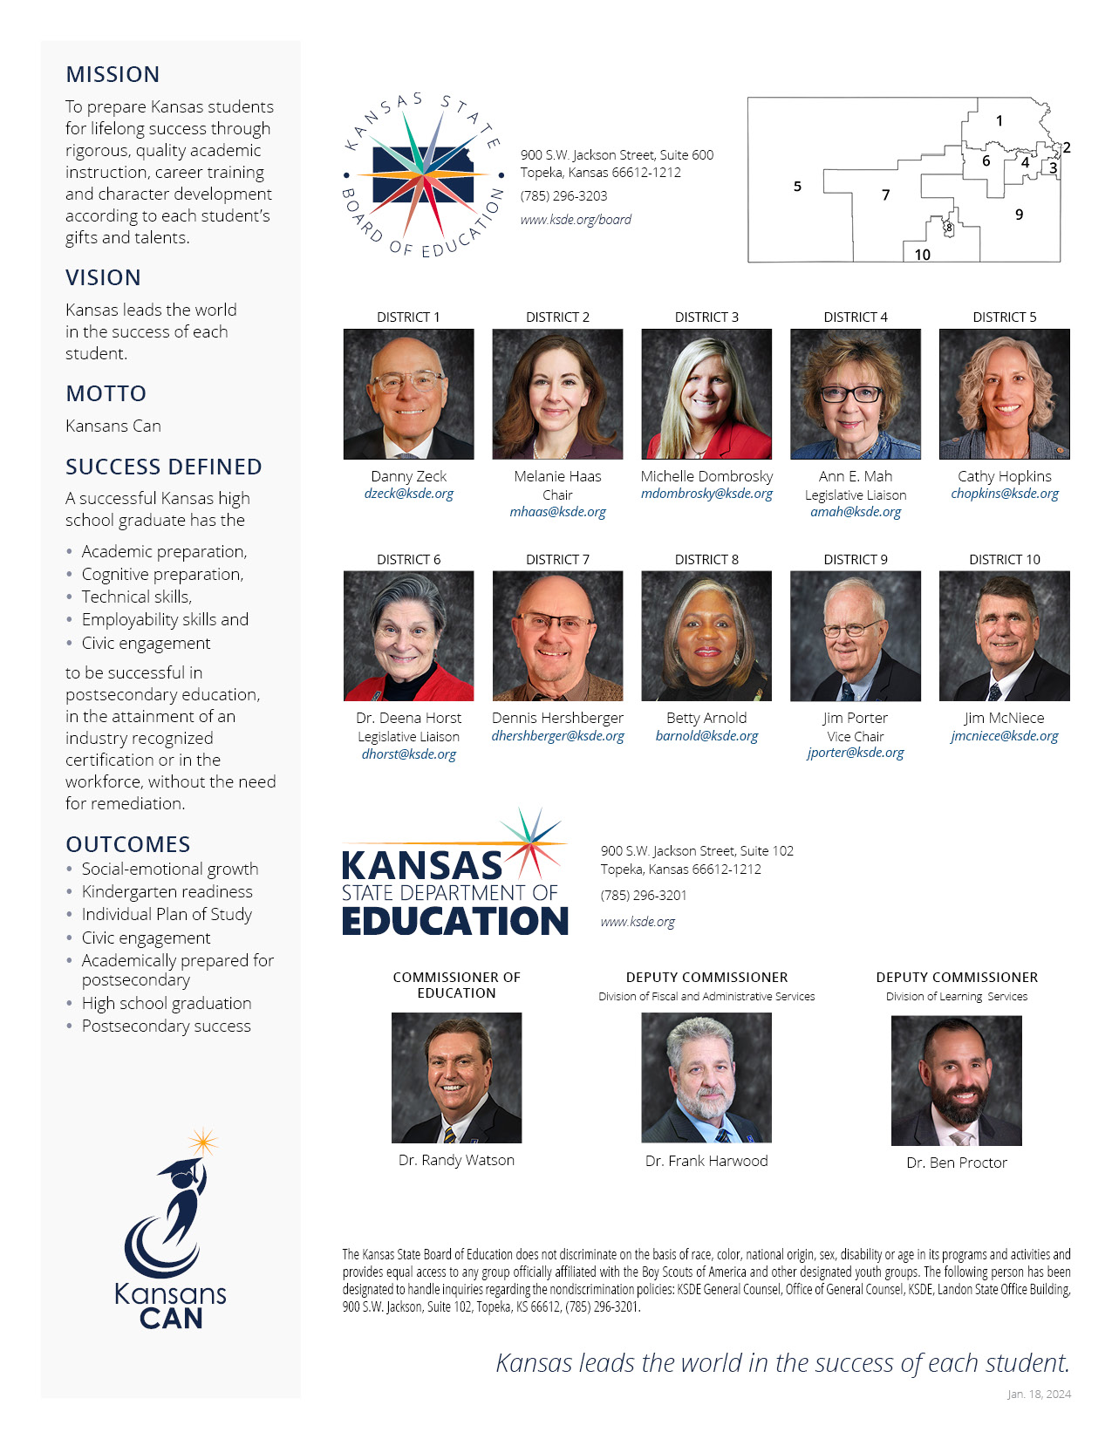

Table of Contents
Perkins Monitoring Process………………………………………………………………………………………1
Perkins Monitoring Process…………………………………………………………………………………………………………….4
Risk-Analysis and Targeted Visits…………………………………………………………………………………………….4
Intended Outcome…………………………………………………………………………………………………………………..5
Primary Goals…………………………………………………………………………………………………………………………..5
Perkins Monitoring Review Forms………………………………………………………………………………………………….6
What will be Monitored?.........................................................................................................................7
On-Site Visits……………………………………………………………………………………………………………………………7
Final Report and Corrective Action…………………………………………………………………………………………8
Perkins Monitoring Review:…………………………………………………………………………………………………………….9
District/Consortium Self-Evaluation…………………………………………………………………………………………..9
Targeted Areas………………………………………………………………………………………………………………………11
Other Targeted Areas……………………………………………………………………………………………………….…..14
Perkins Monitoring Review…………………………………………………………………………………………………………...18
Fiscal Monitoring…………………………………………………………………………………………………………………...18

Perkins Monitoring Process
The Perkins Monitoring Review process combines the efforts of the Career and Technical Education staff at the Kansas State Department of Education (KSDE) and the districts/consortiums as secondary partners.

KSDE/Career and Technical Education staff regularly review the grant activities, outcomes, and expenditures for all federal and state initiatives for which the state receives funding.

Perkins Monitoring Review is conducted during the spring of each year by KSDE staff. Districts/Consortiums to be monitored will be selected on a risk-analysis basis. KSDE staff may conduct additional targeted visits for a district and/or consortium when it is deemed necessary.

Risk-Analysis and Targeted Visits
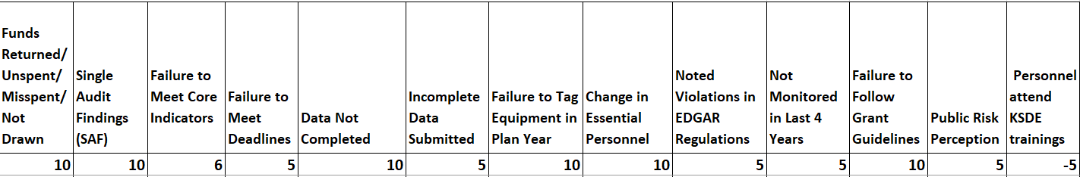
Each district and consortium are evaluated for risk on the following factors:

Using the risk-analysis selection criteria listed above, approximately six to eight desk audits will occur each year. At least two of the districts/consortiums selected for a desk audit will also have an on-site review. On site reviews will occur for districts/consortiums with the highest risk levels and/or concerns arising from the desk audit.

Districts/Consortiums selected for desk audits will be notified by February 15. Districts/Consortiums must complete and submit documentation by March 15. If selected for an on-site visit, notification will occur by April 15. Onsite visits will be completed by May 15.

Intended Outcome
- Review required documentation submitted for state-approved career and technical education program(s) as evidence that verifies program size, scope and quality, and student performance.
- Assure that funds have been expended appropriately and are used in compliance with federal and state policies and legislative mandates.
- Protect against waste, fraud, and abuse.
- Assure expenditures align with the Local Comprehensive Needs Assessment. Ongoing consultation with community partners is expected.
- Identify technical assistance needs.
- Identify promising practices.

Primary Goals
The Perkins Monitoring Review process is designed to:

- Ensure that equal education opportunities are provided to all students, including full opportunity to participate in programs, activities, job opportunities and to benefit from services.
- Monitor the use of federal and state funds, thereby assuring compliance with legislation.
- Ensure Perkins funds supplement local programs not supplant.
- Review and verify accurate data collection and reporting which will result in consistent state-wide data to be reported for Core Performance Indicators.
- Provide technical assistance in the development, implementation and improvement of Career and Technical Education programs and related activities.
- Identify exemplary practices and share this information state-wide.
- Analyze, identify, and change policies and activities that impede the achievement of the above goals.

Perkins Monitoring Review Forms
The purpose of the Carl D. Perkins legislation is to improve the quality of Career and Technical Education programs. Federal legislation specifies that KSDE must monitor the performance of local districts/consortiums receiving funding.

Districts/Consortiums selected for desk audit must submit the following Perkins documents to KSDE by March 15.

- Perkins Monitoring Review: District/Consortium Self-Evaluation
- Electronic copies of all Perkins Expenditures Invoices
- Electronic copies of all Perkins Purchase Requests
- Breakdown of expenses from Perkins Budget page of the annual application
- Electronic copies of previous fiscal year Perkins Accounts
- Time and effort sheets for any employee whose salary is paid through Perkins funds.
- If that person is paid less than 100% from the Perkins grant and/or
- Spends less than 100% of their time on identified Perkins grant activities.
A tour of the district’s CTE facilities may be conducted, if necessary. During the on-site visit, the following items will be reviewed:

- District and program/cluster inventory records
- Verify location of all equipment purchased with Perkins monies.
- Verify that State ID tags are affixed to equipment purchased for $5,000.00 or more.

What will be Monitored?
The District/Consortium Self-Evaluation will monitor for the six uses of the Carl D. Perkins funds. The mandated uses of the funds include:

- Providing Career Exploration and Career Development Activities
- Providing Professional Development
- Provide (within CTE Courses) the skills to pursue careers in high wage, high skill, or in-demand industries
- Integrating Academic and Technical Skills
- Implementing Programs that improve student performance on identified Core Indicators
- Developing and Implementing Local CTE Program Evaluation

The Districts/Consortiums Self Evaluation form includes a section to identify suggested improvement areas and list strategies. Are there some commonalities between the programs/clusters? Are there barriers for some of the programs/clusters? Are there strengths in one program/cluster area that can be integrated into another program/cluster area? Based upon your analysis and an in-depth knowledge about your district, what improvement strategies would you recommend? Districts/Consortiums may use current and trend data to further support the improvement strategies.

On-Site Visits
At least two of the districts/consortiums selected for a desk audit will also have an on-site review. On-site visit includes: 1) an introductory meeting and overview, 2) a review of requested documentation, 3) a review of CTE programs and activities on campus and 4) an exit interview.

During the CTE Programs and Activities review, KSDE staff will:
• Observe CTE classrooms and labs
• Converse with instructors and students
• Review documents
• Review program facility and equipment
• Meet with institutional administrator(s)

All buildings and facilities, especially those operating Career and Technical Education programs, are to be available to the on-site visit team’s observation. Individual and/or group interviews may be requested by the KSDE staff prior to or during an on-site visit.

Final Report and Corrective Action
Following the review of submitted documentation and if applicable on-site visit, a final analysis of documentation is made to determine whether the LEA meets the Federal and State requirements of the Perkins legislation. A final report is sent to the district superintendent or consortium executive director. The district/consortium being monitored must complete and submit a corrective plan of action for any findings KSDE reports within 30 days of receipt of the final report.

Perkins Monitoring Review:

District/Consortium Self-Evaluation

Complete the following document and send electronically to Helen Swanson at hswanson@ksde.org Any items needing to be mailed can be sent to Helen Swanson c/o Kansas State Department Education, Career, Standards and Assessment Services, 900 SW Jackson St. Suite 102, Topeka, Kansas, 66612, to satisfy the desk audit component of the Perkins Monitoring Review.

Institution/Consortium: | USD/Number:
Perkins Contract: | Date:
Contact Number: | FY ___ Funding:

The purpose of the Carl D. Perkins legislation is to improve the quality of Career and Technical Education programs. Federal legislation specifies that the Kansas State Department of Education monitors the performance of local institutions receiving funding.

District Self-Evaluation: Each of the following targeted areas is directly connected to requirements set forth in the Perkins legislation and outlined in your final approved local application. In the space provided, describe activities, projects, and/or services that were carried out during the grant period. Activities, projects, and/or services should align with the final approved application, final performance report and final expenditure report. Based upon analysis and an in-depth knowledge of the district, what improvement strategies are recommended for local activities, projects, and/or services to support the Perkins mandated uses of funds? Include these potential strategies in the space provided.

1. Does the LEA have written policies and procedures outlining how draw requests of federal funds are determined?

2. Does the LEA request federal funds on a reimbursement or projected monthly-need basis?

3. Does the LEA have written procedures in place that minimize the time elapsing between the transfer of funds and disbursement of funds?

4. If interest earned on federal award payments is over $500 for the year, does the LEA follow appropriate procedures for payback? (2 CFR 200.305(b)(8)-(9)
5. Does the LEA identify and track each federal fund separately from other funds?

6. Does the LEA have written policies and procedures to ensure federal funds are used in accordance with all federal requirements of allowable costs?

7. Does the LEA have written policies and procedures covering the use, management, and disposition of property acquired with federal funds?

8. Does the LEA have a system in place to track and inventory all property purchased with federal funds?

9. Has the LEA conducted a physical inventory of the property purchased with federal funds within the last two years? (e.g. supplies, software, computers)

10. Are time and effort certifications collected from staff paid with federal funds?

11. Are the certifications signed by the employee or supervisory official who has firsthand knowledge of the work performed by the employee?

12. Are Personnel Activity Reports or equivalent documentation maintained for employees whose activity is split between multiple cost objectives and whose salaries are supported by federal funds or other funds used to meet maintenance of effort requirements?

13. Does the LEA have policies and procedures that meet or exceed federal retention requirements of five years from the final expenditure report or audit resolution or other action (whichever is later) for the supporting documentation of federal draw requests? Special Education and Title Services Rev. 08/21

14. Is the supporting documentation readily available for review?

15. Did the LEA purchase computers or procurement of software with federal funds?

16. Did the LEA request and receive prior approval from the KSDE?

Targeted Areas
- Administrative Costs

Total Administrative Costs (If Applicable) $_ ___________

- Career Exploration and Career Development Activities

Perkins Legislation: (1) provide career exploration and career development activities through an organized, systematic framework designed to aid students, including in the middle grades, before enrolling and while participating in a career and technical education program, in making informed plans and decisions about future education and career opportunities and programs of study. Section 135 (1) | Funds Expended  $
Activities that supported this mandated use of the funds:

Strategies to be considered for the next annual Perkins Grant application:

- Professional Development

Perkins Legislation: (2) Provide professional development for teachers, faculty, school leaders, administrators, specialized instructional support personnel, career guidance and academic counselors, or paraprofessionals. Section 135 (2) (a-i) | Funds Expended
 | $
Activities that supported this mandated use of the funds:

Strategies to be considered for the next annual Perkins Grant application:

- Provide, within CTE, the skills necessary to pursue careers in high skill, high wage or in demand industries.

Perkins Legislation: (3) Provide within CTE, the skills necessary to pursue careers in high-skill, high-wage, or in demand industry sectors or occupations; Section 135 (3) | Funds Expended
 | $
Activities that supported this mandated use of the funds:

Strategies to be considered for the next annual Perkins Grant application:

- Integration of Academic Skills into CTE Courses or Programs of Study

Perkins Legislation: (4) support integration of academic skills into career and technical education programs/ programs of study to support— Section 135 (4) (a-b) | Funds Expended
 | $
Activities that supported this mandated use of the funds:

Strategies to be considered for the next annual Perkins Grant application:

- Plan and Carry Out Increasing Student Achievement Through Implementation of CTE Programs

Perkins Legislation: (5) plan and carry out elements that support the implementation of CTE programs and programs of study and that result in increasing student achievement of the local levels of performance established under section 113 — Section 135 (5) (a-t) | Funds Expended  $
Activities that supported this mandated use of the funds:

Strategies to be considered for the next annual Perkins Grant application:

- Develop and Implement Evaluations of the Activities Carried Out with Perkins Funds

Perkins Legislation: (6) develop and implement evaluations of the activities carried out with funds under this part, including evaluations necessary to complete the comprehensive needs assessment required under section 134(c) and the local report required under section 113(b)(4)(B). — Section 135 (6) | Funds Expended  $
Activities that supported this mandated use of the funds:

Strategies to be considered for the next annual Perkins Grant application:

Other Targeted Areas
To complete the following section, use data reported in the Pathways System (Summary Report) from the last two fiscal years to respond to each core indicator section.

1. Log into Authenticated Applications
2. Select ‘Pathways’
3. Select ‘Reports’ on the far-left hand side
4. Under CAR Reports, select 'Summary Report’
5. Enter the following information
a. School year – Select the previous two school years prior to the audit
b. Leave Building number, Cluster, Pathway/VE2 Program dropdowns
blank
c. Special Populations – Select ‘All Students’
d. Click PDF or Excel to generate report.

Based upon analysis and an in-depth knowledge of the district, what improvement strategies are recommended to raise the core indicator levels of performance? Include these potential strategies in the space provided.

1S1 Graduation Rate | Required/  State Goal | Actual | Result | Last Year Net
FY
FY

Strategies to be considered for the next annual Perkins Grant application:

2S1 Academic Attainment  Reading | Required/  State Goal | Actual | Result | Last Year Net
FY
FY

Strategies to be considered for the next annual Perkins Grant application:

2S2 Academic Attainment  Math | Required/  State Goal | Actual | Result | Last Year Net
FY
FY

Strategies to be considered for the next annual Perkins Grant application:

2S3 Academic Attainment  Science | Required/  State Goal | Actual | Result | Last Year Net
FY
FY

Strategies to be considered for the next annual Perkins Grant application:

3S1 Total Placement | Required/  State Goal | Actual | Result | Last Year Net
FY
FY

Strategies to be considered for the next annual Perkins Grant application:

4S1 Nontraditional Concentration | Required/  State Goal | Actual | Result | Last Year Net
FY
FY

Strategies to be considered for the next annual Perkins Grant application:

5S2 Postsecondary Credits Attained | Required/  State Goal | Actual | Result | Last Year Net
FY
FY

Strategies to be considered for the next annual Perkins Grant application:

Perkins Monitoring Review

Fiscal Monitoring

For more information, contact: Forward the following materials electronically to Helen Swanson at hswanson@ksde.org Any items needing to be mailed can be sent to Helen Swanson c/o Kansas State Department Education, Career, Standards and Assessment Services, 900 SW Jackson St. Suite 102 Topeka, Kansas, 66612, to satisfy the desk audit component of the Perkins Monitoring Review:
- Perkins Monitoring Review: District/Consortium Self-Evaluation
- Electronic copies of all Perkins Expenditures Invoices
- Electronic copies of all Perkins Purchase Requests
- Breakdown of expenses from Perkins Budget page of the annual application
- Electronic copies of previous fiscal year Perkins Accounts
- Time and effort sheets for any employee whose salary is paid through Perkins funds.
- If that person is paid less than 100% from the Perkins grant and/or
- Spends less than 100% of their time on identified Perkins grant activities.
A tour of the district’s CTE facilities may be conducted, if necessary. During the on-site visit, the following items will be reviewed:
- District and program/cluster inventory records
- Verify location of all equipment purchased with Perkins monies.
- Verify that State ID tags are affixed to equipment purchased for $5,000.00 or more.

Link to Perkins V: Strengthening CTE for 21st Century Act Local Grant Handbook

Helen Swanson  Coordinator  Career, Standards and Assessment  785-296-4912  hswanson@ksde.org |  | Kansas State Department of Education  900 S.W. Jackson Street, Suite 102  Topeka, Kansas 66612-1212  www.ksde.org

