FY 2024 Perkins Secondary Reserve Fund Application Increasing Equitable Access to CTE # 40001
Strengthening Career and Technical Education for the 21st Century
Carl D. Perkins Career and Technical Education Act
Kansas leads the world in the success of each student.

Month Year
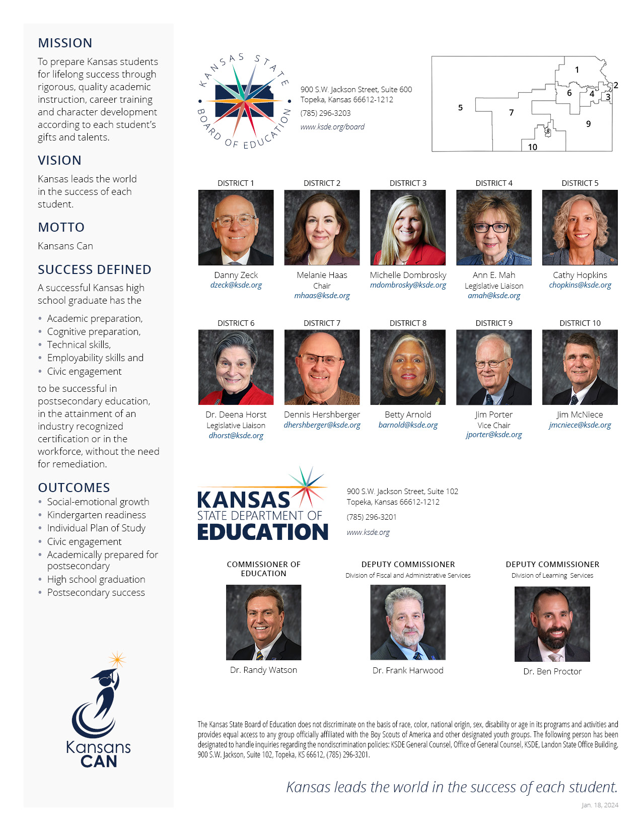

Table of Contents
The Reserve Fund 3
Eligible Recipients 3
Participants 3
Award Period 5
Funding 5
Application Process 5
Submission Requirements 5
Reporting Requirements 5
Failure to Commence 5
Right to Terminate 5
Unused Fund 6
Cover Sheet 7
Reserve Fund Project Activities 8
Project Budget (return with Application) 9
Project Budget Narrative 10
Contractual Provisions 11
Local Assurances 12
Consortium Signature Page 13

Final Budget (return with Final Report) 14
Final Budget Narrative 14

The Reserve Fund
The approved Kansas State Plan for Career and Technical Education (CTE) includes a Perkins Secondary Reserve Fund, established to provide support for innovative CTE programs, program delivery and/or CTE program expansion to meet critical workforce development needs. Reserve funds are distributed through a competitive grant process.
ELIGIBLE RECIPIENTS
Applicants eligible for a Perkins Secondary Reserve Fund grant award:
- Must currently offer approved CTE pathways. AND
- Must meet at least one of the following criteria:
  - Applicants must be in a rural area:
    - “Rural” is a defined as a non-urban area
(urban areas are defined as those Kansas counties with a population of 150 or more persons per square mile).
    - In Kansas, Douglas, Johnson, Leavenworth, Sedgwick, Shawnee, and Wyandotte counties are urban.
    - All other Kansas counties are considered rural for the purposes of the Perkins Grant. OR
- Applicants must have a high number of CTE students
(Concentrators or Participants enrolled in approve Pathways and/or Pathway Courses). OR
- Applicants must have a high percentage of CTE students.
(60% or more of the district’s overall student population in approved Pathways/ courses.)
FUNDING
Goal of Grant
To introduce all students, families, communities, and educators to Clusters at the middle school level; provide access and equity to CTE courses for special population students; increase completers among special population students.

District teams must create teams of the following: middle school principal, middle school counselor, middle school special education staff, high school principal, high school CTE coordinator, high school counselor and high school special education staff.

Required activities:
- Introduce all students, families and educators to career clusters and pathways.
- Collaborate with KSDE specialists in the special population areas that align with the special populations served in the district.
- Collaboration of CTE and special education staff to increase special population enrollment in CTE courses.

Recommended Middle School (5-8) activities:
- Utilize KDOL Labor Market Information with all students focusing on special populations and family engagement.
- Utilize KSDE middle school resources (WBL guide) in curriculum.
- Create hands-on middle school hands projects in collaboration with high school CTE programs.
- Offer a middle school CTE course.
- Utilize 72153 Exploration of Career Pathways or incorporate middle school modules.

Recommend High School (9-12) Charges:
- Create a communication plan to increase CTE enrollment for special population students.
- Translate CTE information in other languages for students and families.
- Utilize KDOL labor market information, O’Net, and KBOR Degree states with all students focusing on special populations and family engagement.
- Collaborate with Workforce Center WBL intermediaries.
- Utilize scope and sequence, goal setting and e-portfolio resources to enhance Incorporate Individual Plans of Study (IPS/Career Development Model).
- Collaborate with postsecondary partners to increase student opportunities for dual credit and Excel in CTE
- Attend K-ACTE Summer Conference – each district will be required to share resources/best practices during a presentation session to increase the number of completers across the state. Information should focus on special population students.

Allowable Expenditures:
Up to $30,000 per stand-alone district/district within a consortium will be awarded.
Allowable expenditures for the project include:
- Stipends for collaboration, planning, and creation of materials
- Supplies (must align to special population enrollment in CTE courses)
- Equipment (must align to special population enrollment in CTE courses)
- Registration at the 2024 KACTE Summer Conference

AWARD PERIOD
This Reserve Fund grant award(s) is for the period March 2024, through May 2024. Drawdown of funds from KSDE must occur no later than June 30, 2024.

APPLICATION PROCESS
Interested, qualified applicants must submit a proposal describing the nature and scope of the project, and the amount of funding requested. Proposals for Reserve Fund grants must include the Cover Sheet; Project Application; Detailed Budget; Budget Narrative; and Completed Assurances Forms. This Perkins Reserve Application must be submitted electronically to: Helen Swanson hswanson@ksde.org no later than 5:00 p.m. local time on February 26. Late proposals will not be considered.
Documents | Due Date | Submit to
Cover Sheet, Application, Project Activities Sheet, Budget, Budget Narrative, and Assurance Forms | February 26, 2024  5:00 p.m. | Helen Swanson  hswanson@ksde.org
Hard copy of all documents w/original signatures, contractual provisions, and local assurances attachments | Upon Request | KSDE CTE- Perkins  900 SW Jackson, Suite 653  Topeka, KS 66612
SUBMISSION REQUIREMENTS

REPORTING REQUIREMENTS
Grant recipients must provide a final narrative, a final project activities sheet, and a final expenditure report no later than July 31, 2024. The applicant or the applicant’s Perkins Coordinator is responsible for ensuring the final report is submitted as required.
FAILURE TO COMMENCE PROJECT
If the project activities described in the grant proposal has not commenced within 30 days after acceptance of the grant award, the recipient must report in writing the steps taken to initiate the project, the reason for the delay, the expected start date, and submit an adjusted project timeline. If project activities have not commenced within 10 days of receipt of the above letter, KSDE may terminate the grant and the recipient will be required to return all unused grant funds with a complete accounting of all expenditures. All funds must be expended by May 30, 2024.
RIGHT TO TERMINATE THE GRANT
After a grant is awarded, any adjustments and/or modifications to the activities or budget amounts must be approved by KSDE prior to the change occurring. Failure to request grant changes in advance may result in the returning of funds expended without approval, and/or termination of the grant. KSDE reserves the right to terminate any grant award and cease payment to the recipient for failure to comply with applicable laws, regulations, and/or terms of the grant assurances. Further, KSDE may seek reimbursement of any or all grant funds and may reclaim any equipment, durable goods and other property purchased with these grant funds if the recipient fails to perform in accordance with the terms of the grant assurances and reporting requirements.
UNUSED FUNDS
All grant funds awarded but not expended by May 30, 2024 must be returned to KSDE within 15 days after of the end of the grant award period.

Cover Sheet

USD and Consortium Name
List Contact Persons
Responsibility | Name & Position | Telephone | Email Address
Application Completer
Administrator
District Clerk/Finance Officer
Provide individual participant information below.
District Name, USD Number,  and Location | Participant Name  (First and Last) | Participant Role | Telephone | Email Address
 |  | Middle School Principal
 |  | Middle School Counselor
 |  | Middle School Special Education Coordinator/Teacher
 |  | High School Principal
 |  | High School Counselor
 |  | High School CTE Coordinator/Teacher
 |  | High School Special Education Coordinator/Teacher
 |  | CTE Pathways and CTE Teacher aligned with each Pathway
Secondary Funding: I understand that if funds become unavailable this application may be terminated. If satisfactory progress and documentation are not made regarding the intended outcomes of this application or if this institution fails to comply with applicable laws, regulations, assurances and/or terms of this grant this application becomes null and void and all funds must be returned. I further understand that supplanting of funds is not allowed under the Carl D. Perkins Career and Technical Education Act.

Administrator’s Signature Date

Reserve Fund Project Activities
District USD: ________ District Name: ___________________________ Consortium____________________________ Grant Year: FY 2024
Responsibility: Start Date: ________________ Completion Date: 05/31/2024
Description of the Activity (What will you do?) Complete this section to include with the application | Fundi$
Expected Result/ Evaluation of the Activity (What is the expected outcome?) Complete this section to include with the application
Final Report/ Activity: (What was the actual outcome?) Complete this section after the conclusion of the grant activities.

Project/ Budget (Return with APPLICATION)

Budgeted Items |  | Number of Items | Item Amount | Total Amounts
- Professional Development (Registration Fees)
Total for Professional Development |  |  |  | $
- Equipment (Items costing $5,000 and more)
Total for Equipment |  |  |  | $
- Supplies (Items costing under $5,000)
Total for Supplies |  |  |  | $
- Other Allowable Expenditures—list separately
 | If administrative costs are taken, amount cannot exceed 5% of the grant total
Total for Other Allowable Expenditures |  |  |  | $
TOTAL FOR PROJECT

State of Kansas
Department of Administration
DA-146a
(Rev. 07-19)

CONTRACTUAL PROVISIONS ATTACHMENT
Important: This form contains mandatory contract provisions and must be attached to or incorporated in all copies of any contractual agreement. If it is attached to the vendor/contractor's standard contract form, then that form must be altered to contain the following provision:
The Provisions found in Contractual Provisions Attachment (Form DA-146a, Rev. 07-19), which is attached hereto, are hereby incorporated in this contract and made a part thereof.

The parties agree that the following provisions are hereby incorporated into the contract to which it is attached and made a part thereof, said contract being the _____ day of ____________________, 20_____.

- Terms Herein Controlling Provisions: It is expressly agreed that the terms of each and every provision in this attachment shall prevail and control over the terms of any other conflicting provision in any other document relating to and a part of the contract in which this attachment is incorporated. Any terms that conflict or could be interpreted to conflict with this attachment are nullified.
- Kansas Law and Venue: This contract shall be subject to, governed by, and construed according to the laws of the State of Kansas, and jurisdiction and venue of any suit in connection with this contract shall reside only in courts located in the State of Kansas.
- Termination Due To Lack Of Funding Appropriation: If, in the judgment of the Director of Accounts and Reports, Department of Administration, sufficient funds are not appropriated to continue the function performed in this agreement and for the payment of the charges hereunder, State may terminate this agreement at the end of its current fiscal year. State agrees to give written notice of termination to contractor at least 30 days prior to the end of its current fiscal year and shall give such notice for a greater period prior to the end of such fiscal year as may be provided in this contract, except that such notice shall not be required prior to 90 days before the end of such fiscal year. Contractor shall have the right, at the end of such fiscal year, to take possession of any equipment provided State under the contract. State will pay to the contractor all regular contractual payments incurred through the end of such fiscal year, plus contractual charges incidental to the return of any such equipment. Upon termination of the agreement by State, title to any such equipment shall revert to contractor at the end of the State's current fiscal year. The termination of the contract pursuant to this paragraph shall not cause any penalty to be charged to the agency or the contractor.
- Disclaimer Of Liability: No provision of this contract will be given effect that attempts to require the State of Kansas or its agencies to defend, hold harmless, or indemnify any contractor or third party for any acts or omissions. The liability of the State of Kansas is defined under the Kansas Tort Claims Act (K.S.A. 75-6101 et seq.).
- Anti-Discrimination Clause: The contractor agrees: (a) to comply with the Kansas Act Against Discrimination (K.S.A. 44-1001 et seq.) and the Kansas Age Discrimination in Employment Act (K.S.A. 44-1111 et seq.) and the applicable provisions of the Americans With Disabilities Act (42 U.S.C. 12101 et seq.) (ADA) and Kansas Executive Order No. 19-02, and to not discriminate against any person because of race, color, gender, sexual orientation, gender identity or expression, religion, national origin, ancestry, age, military or veteran status, disability status, marital or family status, genetic information, or political affiliation that is unrelated to the person’s ability to reasonably perform the duties of a particular job or position; (b) to include in all solicitations or advertisements for employees, the phrase "equal opportunity employer"; (c) to comply with the reporting requirements set out at K.S.A. 44-1031 and K.S.A. 44-1116; (d) to include those provisions in every subcontract or purchase order so that they are binding upon such subcontractor or vendor; (e) that a failure to comply with the reporting requirements of (c) above or if the contractor is found guilty of any violation of such acts by the Kansas Human Rights Commission, such violation shall constitute a breach of contract and the contract may be cancelled, terminated or suspended, in whole or in part, by the contracting state agency or the Kansas Department of Administration; (f) Contractor agrees to comply with all applicable state and federal antidiscrimination laws and regulations;.(g) Contractor agrees all hiring must be on the basis of individual merit and qualifications, and discrimination or harassment of persons for the reasons stated above is prohibited; and (h) if is determined that the contractor has violated the provisions of any portion of this paragraph, such violation shall constitute a breach of contract and the contract may be canceled, terminated, or suspended, in whole or in part, by the contracting state agency or the Kansas Department of Administration.
- Acceptance Of Contract: This contract shall not be considered accepted, approved or otherwise effective until the statutorily required approvals and certifications have been given.
- Arbitration, Damages, Warranties: Notwithstanding any language to the contrary, no interpretation of this contract shall find that the State or its agencies have agreed to binding arbitration, or the payment of damages or penalties. Further, the State of Kansas and its agencies do not agree to pay attorney fees, costs, or late payment charges beyond those available under the Kansas Prompt Payment Act (K.S.A. 75-6403), and no provision will be given effect that attempts to exclude, modify, disclaim or otherwise attempt to limit any damages available to the State of Kansas or its agencies at law, including but not limited to the implied warranties of merchantability and fitness for a particular purpose.
- Representative's Authority to Contract: By signing this contract, the representative of the contractor thereby represents that such person is duly authorized by the contractor to execute this contract on behalf of the contractor and that the contractor agrees to be bound by the provisions thereof.
- Responsibility for Taxes: The State of Kansas and its agencies shall not be responsible for, nor indemnify a contractor for, any federal, state or local taxes which may be imposed or levied upon the subject matter of this contract.
10. Insurance: The State of Kansas and its agencies shall not be required to purchase any insurance against loss or damage to property or any other subject matter relating to this contract, nor shall this contract require them to establish a "self-insurance" fund to protect against any such loss or damage. Subject to the provisions of the Kansas Tort Claims Act (K.S.A. 75-6101 et seq.), the contractor shall bear the risk of any loss or damage to any property in which the contractor holds title.
11. Information: No provision of this contract shall be construed as limiting the Legislative Division of Post Audit from having access to information pursuant to K.S.A. 46-1101 et seq.
12. The Eleventh Amendment: "The Eleventh Amendment is an inherent and incumbent protection with the State of Kansas and need not be reserved, but prudence requires the State to reiterate that nothing related to this contract shall be deemed a waiver of the Eleventh Amendment."
13. Campaign Contributions / Lobbying: Funds provided through a grant award or contract shall not be given or received in exchange for the making of a campaign contribution. No part of the funds provided through this contract shall be used to influence or attempt to influence an officer or employee of any State of Kansas agency or a member of the Legislature regarding any pending legislation or the awarding, extension, continuation, renewal, amendment or modification of any government contract, grant, loan, or cooperative agreement.

LOCAL ASSURANCES/CONTRACTUAL AGREEMENTS
We, as an eligible recipient for funds under the Carl D. Perkins Career and Technical Education, Strengthening Career and Technical Education for the 21st Century Act hereby agree to the following assurances and contractual agreements:
- To administer each program, service, or activity covered in this Carl D. Perkins Career and Technical Education, Strengthening Career and Technical Education for the 21st Century Act, and
- To be in compliance with Executive Order 11246; Title VI of the Civil Rights Act of 1964, as amended; Title IX Regulations; Section 504 of the rehabilitation Act of 1973, as amended; Individuals with Disabilities Education Act and any other federal or state laws, regulations and policies which apply to the operation of the programs. The institution does not discriminate on the basis of sex, race, color, national origin or handicap in the educational programs, services or activities being provided.
- To perform grant fund accounting, auditing monitoring procedures as may be necessary to maintain records as CTE determines to ensure fiscal control, proper management, and proper expenditure of grant funds. The award recipient shall maintain books, records, documents, and other evidence to summarize costs in such a manner so as to identify the costs directly with the delivery of services outlined in the approved grant application. This means that at a minimum the award recipient shall keep records which segregate the grant funds from all other funds received by the award recipient, to keep its accounting for this grant project separate from the accounting of other funds and to spend and report in accordance with the approved grant project budget by program and budget line items. It is understood that this includes invoices and other financial documentation for all paid expenses; the portion of the grant project supplied by other sources of revenue; contracts for services; and other records which facilitate effective grant compliance.
- To assure all records shall be subject at all reasonable times to inspection, review, or audit by State personnel and other personnel duly authorized by KSDE. The award recipient assures that all financial records, supporting documentation, statistical records, and all other records pertinent to the grant award shall be retained by the award recipient for at least five years following the end of the grant project period.
- The award recipient assures that grant funds will not be used to supplant state or local funds.
- If the activities described in the grant application have not commenced within 60 days after acceptance of the grant award, the award recipient shall report in writing the steps taken to initiate the grant project, the reasons for delay and the expected starting date. If the activities have not commenced within 30 days of receipt of the above letter, the award recipient shall submit to CTE a further statement in writing regarding the delay. Upon receipt of the second letter, KSDE may terminate the grant, and the award recipient shall return to KSDE all unused grant funds with a complete accounting of all expenditures.
- KSDE reserves the right to terminate any grant award and cease payment to the award recipient for failure to comply with applicable laws, regulations, and/or terms of the grant assurances. Further, KSDE may seek reimbursement of any or all grant funds and may reclaim durable goods purchased with these grant funds if the award recipient fails to perform in accordance with the terms of the grant assurances and reporting requirements.
- The award recipient shall return to KSDE any grant funds not expended or encumbered by June 30, 2024, within 15 days after the end of the grant project period. assures the Kansas State Department of Education of its intent to comply with the assurances and contractual agreements as outlined in this document. Further, we are willing to explain, in writing, how we intend to comply with each of these assurances and agreements.

USD Name of District

Administrator’s Signature Date

If the district is a part of a consortium, the following must be completed.

The _____________________________ Consortium has reviewed this Perkins Reserve Grant Application from ____________________________ (list USD number and district name).

Check one of the following:

o The _____________________________ Consortium supports this application and will act as the fiscal agent for ______________________________(list USD number and district name) in the administration of this reserve grant if awarded.

o The _____________________________ Consortium supports this application, but does not have capacity to provide the administration of this reserve grant on behalf of ______________________________ (list USD number and district name). ______________________________ (list USD number and district name) will be the responsible fiscal agent for administration of this reserve grant if awarded.

Consortium Fiscal Agent signature: ________________________________________________________
Date: _____________________________________

FINAL Reserve Fund Budget Sheet
(Complete and return with FINAL REPORT)
Budgeted Items |  | Number of Items | Item Amount | Total Amounts
- Professional Development (Registration Fees)
Total for Professional Development |  |  |  | $
- Equipment (Items costing $5,000 and more)
Total for Equipment |  |  |  | $
- Supplies (Items costing under $5,000)
Total for Supplies |  |  |  | $
- Other Allowable Expenditures—list separately
 | If administrative costs are taken, amount cannot exceed 5% of the grant total
Total for Other Allowable Expenditures |  |  |  | $
TOTAL FOR PROJECT

Final Project/Budget Narrative (Return as Final Report)
DESCRIBE the outcome of the professional development:
Please explain how the activity progressed, define the actual results, and provide the evaluation of the activity.

