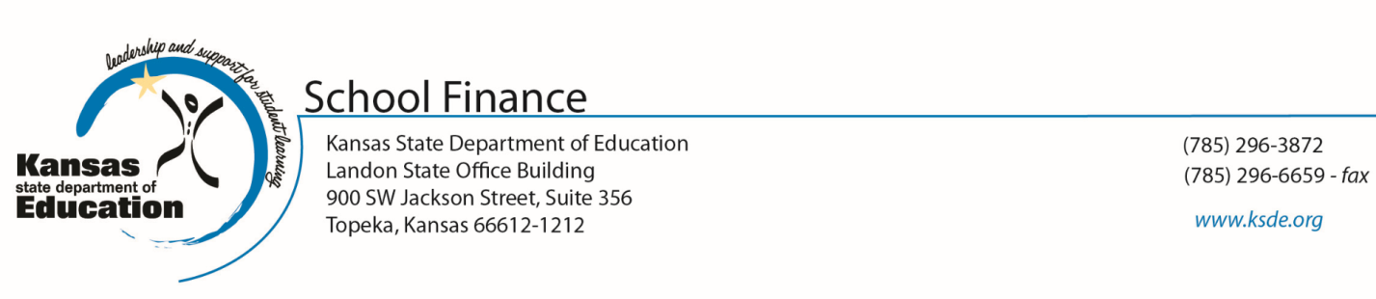
August 2014

To: Chief School Administrators

From: Dale M. Dennis, Deputy Commissioner
Division of Fiscal and Administrative Services

Craig Neuenswander, Director - School Finance

Subject: Local Option Budget

Beginning in the 2007-08 school year, a school district was authorized the statewide average LOB percent or the authority granted under other provisions of the law, whichever is higher.

In 2014-2015, the statewide average is 30%.

The maximum LOB authorized percent for 2015-2016 is 33%, however, in order to access the additional 3% (30% to 33%), a vote to increase the LOB must be held and approved by the patrons of the district. The vote must occur by mail ballot election. If your unified school district decides to adopt a local option budget in excess of 30%, you must publish a resolution and hold a mail ballot election to increase LOB authority to 33%. Attached is an example of a resolution.

We hope this information will be of assistance to you. If you have any questions, feel free to contact our office.

Note: A school district does not have to publish a resolution if they choose to use only the LOB authority granted by the grandfather clause for the statewide average LOB authority of 30%.

If your unified school district decides to adopt a local option budget in excess of 30%, you must publish a resolution and hold a mail ballot election to increase LOB authority to a maximum of 33%.

BOARD OF EDUCATION
Unified School District No. _____
______________ County, Kansas

Resolution to Adopt a Local Option Budget

WHEREAS, the Board of Education of Unified School District No. ______, ______________ County, State of Kansas, currently has authority to adopt a local option budget of 30.00 percent of the general fund for use by the district; and

WHEREAS, the Board of Education of Unified School District No. ______, ______________ County, State of Kansas, has determined that a local option budget of 33.00 percent of the general fund would be in the best interests of the district; and

WHEREAS, the Board of Education of Unified School District No. _____, ______________ County, State of Kansas, is authorized by K.S.A 72-6433 and K.S.A. 72-6434, as amended, to adopt such a local option budget in an amount not to exceed 33% of the state financial aid determined for the district in the current school year; and

WHEREAS, the adoption of the amount of local option budget in excess of 30% shall be effective only if submitted to and approved by a majority of the qualified electors of the School District at a mail ballot election called and held in the manner provided by K.S.A. 10-120 and amendments thereto; and

WHEREAS, the Board of Education of Unified School District No. ______, ______________ County, State of Kansas, has determined to exercise the authority vested in it by said law;

NOW, THEREFORE, BE IT RESOLVED, that the Board of Education of Unified School District No. ____, ______________ County, State of Kansas, shall be authorized to adopt a local option budget in any school year in an amount not to exceed 33% of the amount of state financial aid determined for the current school year, and that this authorization shall cease after the _______ fiscal year (or continuous and permanent). The local option budget authorized by this resolution may be adopted, after approval by a majority of the qualified electors of the School District at a mail ballot election called and held thereon.

BE IT FURTHER RESOLVED THAT, the Board of Education of Unified School
District No. ______, ______________ County, State of Kansas, does hereby call for a mail ballot election on the following question and requests that said question be placed on the ballot for an election scheduled for ________________, 20___.

# # #

BALLOT LANGUAGE

“Shall the Board of Education of Unified School District No. ____, ______________ County, State of Kansas, be authorized to increase its local option budget authority by an additional 3% (from 30% to 33%) of its state financial aid?”

To vote in favor, vote “YES”

To vote against, vote “NO”

CERTIFICATE

THIS IS TO CERTIFY that the above resolution was duly adopted by the Board of Education of Unified School District No. _____, ______________ County, State of Kansas, on the ______ day of ______________, 20____.

___________________________
Clerk, Board of Education

H:forms/LOB Resolution

