May 15th to August 15th Submission Window
This document contains the steps to assign students to pathways and update the student statuses as participants or concentrators for the current school year.
The upload specifications are at the end of the document.
For assistance, contact pathwayshelpdesk@ksde.org or call (785) 296-4908.

Beginning Student Data Management
1. Visit https://apps.ksde.org/authentication/login.aspx to get access to Pathways.
2. First time users should register and choose an access level of “School Approve” or “District/Org Update.” Your access request will need approval from your superintendent. District access will only be listed after selecting “All Buildings” in the building field drop down menu.
3. If you need to change your access level from School Update to School Approve, select Manage My Account after logging in. This access change will need approval from your superintendent as well.
4. After login on the KSDE Web Applications page, select the link “Pathways.”
If needed, The Pathways report Student Career Course Completion will help you gather student data.

Assign Students to Pathways
5. Click on “My CPPSAs” in the left menu.
6. Change the “School Year” to the school year that has ended.
7. Mark the Status box “Approved by KSDE.”
8. Click the “View/Filter CPPSAs” button.
9. Under Actions, click on “Assign Students” next to the pathway that needs students assigned.
(Please note that each pathway must be assigned/updated individually)
10. Place a check mark in the box for students that have at least 1 credit in this pathway. All the
students that are listed have an KCAN record submitted in the KIDS system. The second
column will show the suggested pathway based on courses taken this school year.
11. If a student’s name is missing from the Assign Students screen, click on the “Show All Students” link at
the top of the page. This should show all CTE students in your school building.
12. Student assignments save automatically. Students can only be assigned to one pathway.
Please give first consideration to any Non-Traditional (Gender) pathway. Districts will always
have final decision on the Pathway assigned for each student.
13. Repeat steps for all pathways.

Update Current Student Status
14. Click on “Update Students” link at the bottom of the page or repeat steps 1-4, then under the Actions column, click on “Update Current Students” next to the pathway that needs updated.
15. Select the single parent status as yes if the student is pregnant or a parent currently.
16. The student’s status from the previous year will roll over. They may need a status updated.

Select the status below for the student.
  - Participant: A student who has earned one (1) but less than two (2) secondary level credits in a single career and technical education (CTE) pathway.
  - Concentrator: A student who has earned two (2) or more secondary level credits in a single CTE pathway, with those credits within any combination of two levels AND has met at least 70% proficiency on the technical skills across those 2.0 credits through several technical skill measures (avg % of letter grades OR passing % of end-of- course assessments or projects OR avg % on competency profiles, etc.).
  - Concentrator who Exited: A student who has met the criteria to be considered a concentrator AND has graduated secondary education with their cohort class.
  - Concentrator who Exited for Other Reasons: A student who has met the criteria to be considered a concentrator who exited but has either 1) not met at least 70% of the competencies by graduation or 2) will not graduate with their cohort class. The reasons for this include but are not limited to the student: transferring out of district, dropping out of high school, or passing away.
  - COMPLETER: A student who has completed a minimum of three (3) secondary level credits in a single CTE pathway, with at least two (2) of those credits being a combination of technical and application-level courses. A Completer must also earn or complete at least one or more of the following: Earn an end of pathway assessment/certification for completer status (industry-recognized certification or a passing score on a third-party, end-of-pathway assessment); earn an Excel in CTE Qualifying Recognized Credential aligned to the Pathway; earn nine (9) + college hours leading to completion of a certificate or post-secondary program aligned to the Pathway’s Program of Study; and/or complete a high-quality work-based learning career preparation experience, Kansas Work-Based Learning Continuum, in the Pathway defined in Kansas Work-Based Learning: Personalized Learning Plan Guidance Document (ksde.org).

17. When selecting “concentrator who exited”, please indicate the competency percentage achieved
or pass/fail for the 3rd party assessment.
18. When selecting “concentrator who exited for other reasons”, list the reason in the box.
19. If there are not any concentrators in a pathway, fill out the “No assigned concentrator’s comment
section.”
20. Report the status for all students who qualify in only one pathway per federal law. Click “Submit.”
Please submit often if you have a long list of students.
21. Repeat for all approved pathways in the district.

(Optional) Upload Assign/Update File

Any data uploaded in Pathways on the Assign Students Screen must contain proper linking information and can be in the format of Comma-Separated Values (.csv) only. All columns must have a number or space entered.
- Click on Browse at the bottom of the Update Students page.
- Upload the CSV File and click on “Open” in the “Choose File to Upload” screen.
Check data on Update Student screen, if needed.

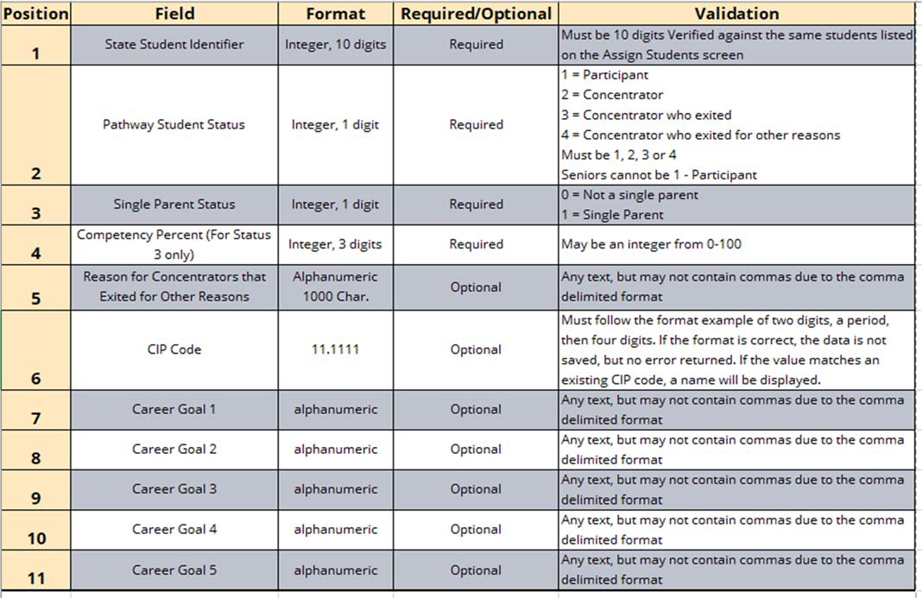

Kansas State Department of Education | 900 S.W. Jackson Street, Suite 102 | Topeka, Kansas 66612-1212 | (785) 296-3201 | www.ksde.org
The Kansas State Department of Education does not discriminate on the basis of race, color, religion, national origin, sex, disability or age in its programs and activities and provides equal access to the Boy Scouts and other designated youth groups. The following person has been designated to handle inquiries regarding the nondiscrimination policies: KSDE General Counsel, Office of General Counsel, KSDE, Landon State Office Building, 900 S.W. Jackson, Suite 102, Topeka, KS 66612, (785) 296-3201.

